5th Year MEng Research Project Final Report

*Computer vision software to identify car wheels in real-time using limited hardware.*

December 2020



David Richard Gladwell

MEng Autonomous, Interactive and Robotics Systems

**Abstract**

The following report discusses the research and implementation of camera-based Car Wheel detection software. The removal of car wheels is a strenuous and repetitive task undertaken in car garages around the world. The automation of such a task is beneficial to the garage workers who no longer need to strain their backs. Additionally, innumerable man-hours can be redirected to other endeavours. To automate this task a robot capable of autonomous identification, navigation and removal of car wheels needs to be built. This project investigates the autonomous identification of a car wheels. The first criteria of the project was to create object detection software for real world car wheels that is high precision. This was achieved with a cascade classifier that identifies potential car wheel bounding boxes in a video feed and a CNN that verifies if these bounding boxes contain a car wheel. A precision rate of 96% was obtained on a test set of 100 car images and 100 non-car images. The second criteria of the project was for the software to work in real-time on limited hardware. This was only possible through multithreading and bounding box tracking. As a result, the software leverages the accuracy of state-of-the-art computer vision software to identify new car wheels and tracks these bounding boxes using less demanding software to maintain real-time capability. This results in code that is precise and fast so long as the bounding box tracking doesn’t make a mistake.

**Table of Contents**

Chapter 1 : Introduction 1

Section 1.1 : Challenge and wider project 1

Section 1.2 : Main criteria when developing a car wheel detector 1

Section 1.3 : Contribution of the final software to the wider project 2

Chapter 2 : Theory 3

Section 2.1 : Summary 3

Section 2.2 : Low-level computer vision 4

2.2.1 : Intro 4

2.2.2 : Digital image 4

2.2.3 : Thresholding 5

2.2.4 : Resizing 6

2.2.5 : Convolution 8

2.2.6 : Canny edge detection 10

Section 2.3 : Hough Transforms 11

2.3.1 : Intro 11

2.3.2 : Hough Transform 11

2.3.3 : Hough Circle Transform 12

Section 2.4 : Feature detection: 13

2.4.1 : Intro 13

2.4.2 : Key points 14

The figure above shows 3 examples of an original image and its 15

2.4.3 : Descriptors 15

2.4.4 : Matching descriptors 15

Section 2.5 : Machine learning: 17

2.5.1 : Intro 17

2.5.2 : How machine space learning is used in computer vision 17

2.5.3 : Cascade Classifier 18

2.5.4 : Convolutional Neural Network (CNN) 20

Chapter 3 : Low-level computer vision experimentation 25

Section 3.1 : Introduction 25

Section 3.2 : Edge detection and contour matching 25

3.2.1 : Intro 25

3.2.2 : Brief code structure 25

3.2.3 : Results 26

3.2.4 : Conclusion 26

Section 3.3 : Hough Transform: 26

3.3.1 : Introduction 26

3.3.2 : Brief code structure 26

3.3.3 : Results 27

3.3.4 : Conclusion 28

Chapter 4 : Intermediate level computer vision experimentation 29

Section 4.1 : Summary 29

Section 4.2 : Feature detection and matching 29

4.2.1 : Intro 29

4.2.2 : Making features and matching them 29

4.2.3 : Use in final implementation 30

4.2.4 : Results 31

4.2.5 : Conclusion 32

Chapter 5 : High level computer vision experimentation 33

Section 5.1 : Summary 33

Section 5.2 : Cascade Classifier 33

5.2.1 : Intro 33

5.2.2 : Data preparation 33

5.2.3 : Training the model 34

5.2.4 : Usage of the cascade model 35

5.2.5 : Results 35

5.2.6 : Conclusion 35

Section 5.3 : CNN with logistic regression models for image classification 36

5.3.1 : Intro 36

5.3.2 : Direct transfer learning on CNN 36

5.3.3 : Transfer learning on CNN with machine learning and feature vectors: 38

5.3.4 : Brief code structure: 39

5.3.5 : Results 39

5.3.6 : Conclusion 39

Chapter 6 : Working implementation of car wheel detection 41

Section 6.1 : Summary 41

Section 6.2 : The main loop and video stream reader 41

6.2.1 : Intro 41

6.2.2 : Video stream resizing 41

6.2.3 : Additional features 42

Section 6.3 : Car wheel proposal areas and confirmation 43

6.3.1 : Car wheel proposal areas 43

6.3.2 : Car wheel confirmation 43

Section 6.4 : Draw the bounding boxes: 44

6.4.1 : Overview 44

Section 6.5 : Code optimisation: 44

6.5.1 : Intro: 44

6.5.2 : None threaded 45

6.5.3 : Threaded 45

Chapter 7 : Performance and Discussion 48

7.1.1 : Performance of Cascade and CNN object detection pipeline 48

7.1.2 : Overall car wheel detection software performance 49

Chapter 8 : Conclusion 51

Section 8.1 : What was achieved 51

Section 8.2 : Recommended future work 51

8.2.1 : Most important work 51

8.2.2 : Improvements on the car wheel detection models 51

8.2.3 : Other recommendations 52

Chapter 9 : Annex 53

Section 9.1 : Hardware and software setup 53

Section 9.2 : Link to Code 53

Section 9.3 : link to Data sets 53

Section 9.4 : Plan of work 53

Section 9.5 : References: 53

Section 9.6 : Figure References: 55

**List of Figures**

Figure 1: A bounding box around identified car wheel. Note that the name of the bounding box is categorical, but a unique ID was also given. 10

Figure 2: Picture of a grayscale image and how it’s represented as a 2D array. 11

Figure 3: Image of how a typical BGR image is formatted. 12

Figure 4: Image of the 3 colour channels. Coloured screens have pixels composed of these 3 colour components. 12

Figure 5: Example of global thresholding. 13

[Figure 6: Image showing the first step of image resizing, which is too find the location of the resized image pixels relative the original image pixels. 13](https://heriotwatt-my.sharepoint.com/personal/drg1_hw_ac_uk/Documents/Car%20Wheel%20Detection%20final%20report.docx#_Toc59201637)

Figure 7: Image of a 1-Dimension array of 2 original points being made into a 1 point. This would be a form of downscaling (making the image smaller). 14

Figure 8: Linear Interpolation formula. 14

Figure 9: Bilinear interpolation. 14

Figure 10: Convolution of the pixel (1,1). 15

Figure 11: An example of a 3D Gaussian. 15

[Figure 12: A 3x3 gaussian blur kernel and 5x5 gaussian blur kernel, respectively. The fraction on the side of the kernel represents the factor by which each pixel value is multiplied. The denominator of the fraction is the sum of the weights in its kernel. 16](https://heriotwatt-my.sharepoint.com/personal/drg1_hw_ac_uk/Documents/Car%20Wheel%20Detection%20final%20report.docx#_Toc59201643)

Figure 13: To the left a vertical Sobel filter, to the right a horizontal Sobel filter. 16

Figure 14: Original image being processed on vertical and horizontal Sobel filters respectively. 17

Figure 15: The image on the left is the input image and the image on the right is the output of the Canny edge detector. 17

Figure 16: Image on the left of two points in cartesian space. The image on the right represents the Hough line transform of both these points. Note how the curves cross at one unique point between -90 ° θ to +90° θ [4]. 18

Figure 17: Original image top left, the edge map of the original image, the Hough transform of the edge map [4]. 19

Figure 18: Hough transform for a circle of fixed radius [5]. 20

Figure 19: ORB feature matching of two different images of the same book. 21

Figure 20: Difference of Gaussians (DoG) [3]. 22

Figure 21: Three auto-correlation surfaces showing both grayscale images and surface plots [3]. 22

Figure 22: Histogram of gradients for a patch of an image [3]. 23

Figure 23: Example of RANSAC used to find the line equation that best fits the data points and algorithm pipeline. 23

Figure 24: Example of a DATA set. Not that the first row of the table is called a header. This provides the name of each attribute. There is no clear column that is an in this example label. 25

Figure 25: Visualization of gradient descent for an ML algorithm with one weight. The cost represents the error and W represents the value of the one weight. 25

[Figure 26: (Left) the two features are used in the first layer of the cascade classifier face detection model trained by Viola & Jones. (Right) examples of 4 different features that can be used by the Cascade Classifier Algorithm [12]. 27](https://heriotwatt-my.sharepoint.com/personal/drg1_hw_ac_uk/Documents/Car%20Wheel%20Detection%20final%20report.docx#_Toc59201657)

Figure 27: Performance of the Cascade Classifier relative to other object detection algorithms [12]. 28

Figure 28: Example of a feed-forward Artificial Neural Network. The circles are the neurons, and the arrows are the connections and direction of stimulation. 29

Figure 29: example of a neuron showing the in input (x1-xn), their corresponding weights (w1-wn), a bias (b) and the activation function f applied to the weighted sum of the inputs. 30

Figure 30: Example of conventional CNN. 31

Figure 31: Left is the edge detection; right is the hubcap contour boundary and centre. 2

Figure 32: OpenCV HoughCircles method official documentation. 3

Figure 33: Example of successful Hough Circle Detection on car wheel. 3

Figure 34: Examples of Hough Circle Detection failures on car wheel images. 4

Figure 35: (left) The best descriptor pairs key-points, (right) the matches that line up for the best homography matrix. The number of matches on the right show this is a good match. 7

Figure 36: (top ) The best descriptor pairs key-points, (bottom) is the matches that line up for the homography matrix. The number of matches on the bottom show this is a bad match. 7

Figure 37: Transformed image of the car wheels of figure 36. The best homography matrix generated with RANSAC is used to transform the image. 8

Figure 38: Image of the last data preparation step. The command in the last line of the terminal would start the training of a car wheel detecting Cascade Classifier. 10

Figure 39: Example of the terminal during training. With the default setting the classifier will attempt to learn features that achieve a false positive rate bellow 0.2 and a true positive rate above 0.99. 11

Figure 40: Code for running the CNN in a thread. 22

Figure 41: Visualisation of the intersection over union formula. 24

Figure 42: Example of common mistake produced during testing of car wheel detection software. 25

**List of tables**

Table 1: The results table of the Cascade classifier. 11

Table 2: Table of available prebuilt and trained models on Keras [21]. 13

Table 3: Confusion matrix of the CNN with Logistic regression model used for transfer learning. 15

Table 4: The results table of the Cascade classifier. 24

Introduction

* 1. Challenge and wider project

An autonomous car wheel removing robot is being developed to assist mechanics in replacing car wheels in a garage environment. The robot is a mobile platform equipped with a tray to pick up car wheels and a robotic arm. When the full project is finished the robot will reduce the workload for mechanics or allow them to focus on other more technical tasks. Car wheel removal work can be strenuous on garage workers’ backs if performed continuously each day. Having a robot to assist in the garage will increase job comfort and overall health. Having robots work harmoniously in a busy workplace with humans remains at the frontier of what is technologically achievable. The potential productivity and job quality improvements that a blended human-robot workforce can achieve is world changing. The potential benefits a car wheel removal robot brings to garage workers and robotics research is a strong incentive for seeing this project be made into a success. To this end, the robot needs the ability to perceive its local environment. Without a mean to deduce information from the world around it, full autonomy for the robot is impossible. A camera sensor is used to perceive the local environment of the robot. Hence computer vision techniques were used to develop the car wheel detection software. “Computer vision trains machines to perform these functions, but it does it in much less time with cameras, data and algorithms rather than retinas, optic nerves and visual cortex.” [1].

## Main criteria when developing a car wheel detector

The detector has to cope with a variety of car wheel types, car wheel orientation, lighting and scale. The scale is the size of the wheel projection on the camera sensor, the closer the wheel the bigger the projection and scale. These issues are worsened by the reality that the area above and below car wheels are gray so there is a lack of distinction between these areas and the wheel. This makes spotting a wheel with computer vision a challenge. The software must generalise well and remain invariant to changes in car wheel types, car wheel orientation, lighting, scale.

A couple of limitations impacted the project, there was no way to access a graphical processing unit. This hardware is almost mandatory for state-of-the-art computer vision. There were also a lot of new concepts to learn. Hence why the plan was to experiment with simple solutions before moving onto state-of-the-art solutions. As a result, one of the criteria is for the software to require very low computation power and work in real-time.

Initial criteria for car wheel recognition software is good accuracy, more specifically a low false-positive rate. If a false-positive was made the robot could try and remove a wheel from a car door, or even worse, a garage worker, which is of course unacceptable. The robot needs to work correctly on real-world car wheels otherwise it would be impractical to use it in the wider project and must be redone.

The software produced as a result of the project must meet all these criteria. Some compromises had to be made, as a low false-positive rate and low computation demands are difficult to achieve at the same time.

## Contribution of the final software to the wider project

This projects computer vision software provides a means of identifying a car wheel with a camera, running real-time on an average laptop CPU at 11 fps. The car wheel detection software can identify real-world car wheels with an accuracy of 97%. This number was obtained with a test set of 100 car wheels and 100 non-car wheels images. In this test, all 100 of the car wheels were identified and only 6 false-positives were made. The threshold for what the software counts as a car wheel can be raised to decrease the number of false-positives. This comes at a cost of decreasing the true-positive rate which is currently at 100%. In a final version of the car wheel removing robot 96% accuracy rate would be unacceptable. However, this number is more than sufficient to continue the development of the wider robot project in other areas such as navigation or hub cap and lug nut identification. Future teams using this code will run the main loop of the code and make calls to its getter method to obtain the current car wheel(s) on the robot cameras: name(s), bounding box(s) and bounding box centre(s).

Additionally, a computer vision object detection pipeline has been implemented and can be improved upon. The object detections’ pipeline ability to run on an average CPU has been achieved with multithreading and bounding box tracking. There are some drawbacks to this implementation. Namely, the bounding box tracking only makes an educated guess on whether or not a potential bounding box in the video feed contains a previously seen car wheel. Whilst no formal way of testing the performance of this technique was easily feasible, empirical evidence demonstrates it running quite well. Car wheel detection does not work well when the camera moves quickly. In practice though, the camera will not move as fast when the robot is moving around a garage. An indirect benefit of the bounding box tracking is that the software can distinguish car wheels from one another in the video feed. Also, it can identify car wheels that have gone off the screen temporarily.

This report explores a variety of computer vision techniques and provides recommendations for the future of the computer vision aspect of the car wheel removal robot. Lastly, the dataset created for this project has 1350 positive and negative car wheels. These are images with bounding box constraints for the 1350 car wheels in their original images. These datasets can be reused and expanded in future work as well.

# Theory

## Summary

This project comes from a field of research known as computer vision. The field started in the summer of 1966 when the MIT professor Seymour Papert set up a summer project to tackle some of the major milestones in computer vision. [2] The project proved to be tougher than first anticipated. As a result, computer vision has remained an active field of research with great strides of progress occurring in just this last decade thanks to advances in hardware and artificial neural network architecture. Identification of car wheels in an image requires object detection, this subcategory of computer vision returns the locations and name of a detected object in an image. The location is shown with a bounding box, which as the name implies is a box that bounds the found object. The name of the object is usually categorical and is referred to as the “class” of an object.

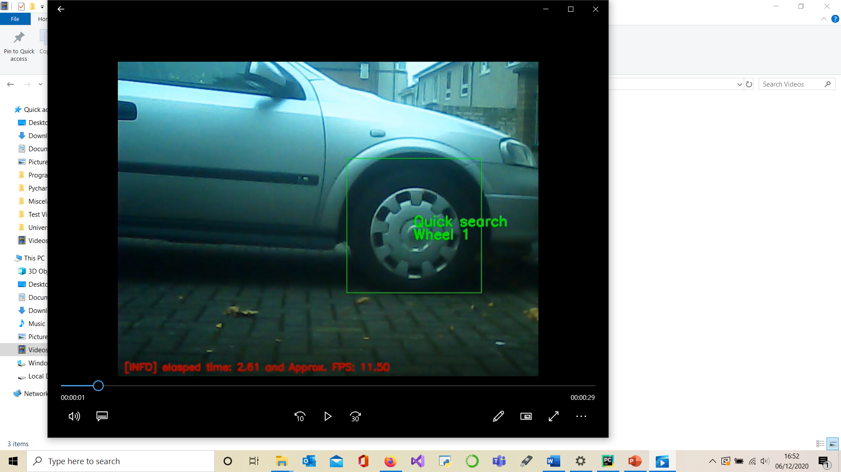

Figure 1: A bounding box around the identified car wheel. Note that the name of the bounding box is categorical, but a unique ID was also given.

In this project, binary classification is being performed; there either is a car wheel or there is not. Thus, there is no need to return the class name of the bounding box. So, the name “wheel 1” in the picture above refers to a unique car wheel object rather than a category. The research conducted for this project covers large breadths of computer vision, ranging from older and more “basic” techniques to new developments. For the latter, convolutional neural networks trained with transfer learning was researched and implemented. The reason for starting with low-level computer vision (CV) and then moving to high-level CV is twofold. Firstly, the state-of-the-art techniques which typically pertain to high-level CV build upon ideas and tools developed in low-level and intermediate-level computer vision. Thus, a general knowledge of computer vision is preferable before attempting to implement high-level CV software. Secondly, state-of-the-art software demands more computing power to run. This is problematic for real-time applications, which is the case for this project. Thus, simpler computer vision techniques were experimented with first in a bid to lower the final solutions hardware demands. The software solution built during this project does make use of low level, intermediate and high-level computer vision to achieve both accuracy and speed on limited hardware.

* 1. Low-level computer vision
     1. Introduction

Low-level computer vision operates on just pixel values. This can be photo manipulation such as resizing, making the image black and white or changing the saturation levels of the image. It can also feature extraction such as detecting edges or thresholding where only certain colours are visible.

* + 1. Digital image

A digital image is composed of a grid of pixels. This is different from traditional images which are continuous and are not made of discrete elements. In a typical black and white image, the pixels can be in 256 (= $2^{8})$ different states. Sometimes these intensity values are set in a range between 0-1, which is a floating-point value instead of a byte. Starting from a value of 0, the pixel is completely black and going all the way to a value of 255 the pixel is completely white. A black and white image, or as it is more commonly called a grayscale image is represented as a multidimensional array. The 2-D array will have “height” and “width” dimensions which together represent a grid cell. The numerical value in this grid cell is the intensity value.

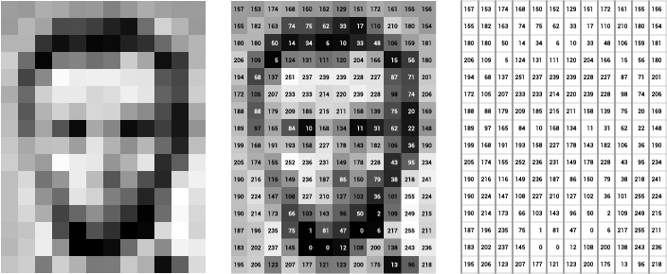

Figure 2: Picture of a grayscale image and how it’s represented as a 2D array.

Reiterating, the height and width represent the number of pixels in the rows and columns of a digital image, respectively. The ordering of the dimensions inside the array is arbitrary, consistency is the objective. Typically, the top left of an image is the starting point for width and height. With a coloured imaged an extra dimension is added to the 2-D array called channels. The channels will typically be RGB format: Red, Blue, Green. Other formats exist where the ordering is different, such as BGR.

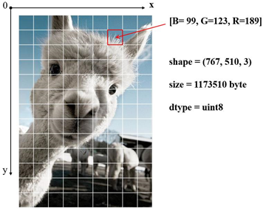

Figure 3: Image of how a typical BGR image is formatted.

Additionally, other colour models can be used such an HSV (Hue, Saturation, Value) which represent a coloured pixel differently. Either way, a coloured image is represented in a 3-Dimension array with “height”, “width” and “channel” dimensions. With the elements of the array being defined by the colour model. This will typically result in a Blue, Green and Red colour values, each in a range from 0-255. The ordering can vary from software to software.

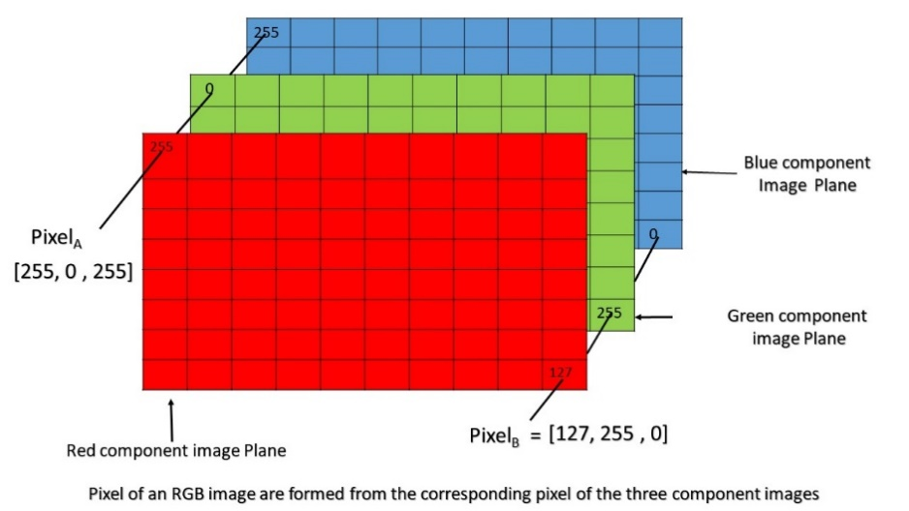

Figure 4: Image of the 3 colour channels. Coloured screens have pixels composed of these 3 colour components.

* + 1. Thresholding

This is an operation in which pixels of certain intensities are ignored or made into an arbitrary colour. For example, when trying to find an “orange” ball in an image, thresholding can be used to ignore non-orange colours. This is done by establishing what range of values the colour orange exists in. Still considering the colour orange in the Red, Green and Blue colour format, the range is approximately from (245, 140, 0) to (255, 190, 30). These values are obtained by taking arbitrary values above and below the searched for colour. In this case, the orange ball has value intensities of Red = 255, Green = 165, and Blue = 0. There lies the big issue with thresholding, exact RGB values usually cannot be given as different cameras, and lighting conditions will subtly change the colour of the orange ball. The solution is to input a range of orange values to threshold for rather than a single shade of orange. An important trade-off is done here which is echoed throughout computer vision. If the orange range is too small the ball might not be identified, if the range is too wide other non-ball objects might be spotted. The trade-off impacts how many true-positives (orange balls) are found and how many false-positives (non-orange balls) are found. Whilst this is a limitation, in a controlled environment with predictable lighting this is less of an issue. A typical thresholding operation will result in an image where the pixels which fall into a specified range are either the subject of some form of operation or ignored in an operation.

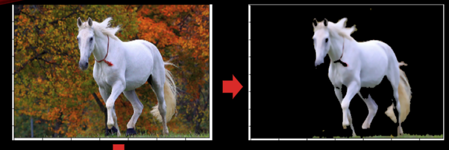

Figure 5: Example of global thresholding.

What has been discussed thus far is Global thresholding, which is an operation that works the same way across the entire image. Adaptive thresholding changes its values for different sections of the image. By adapting the threshold range in a local area, variations of lighting can be compensated for, yielding a better output image. Thresholding an image is a useful tool for simplifying the information in an image and thus simplifying other computer vision problems.

* + 1. Resizing

Resizing an image goes in two directions. The image can be made bigger or smaller. To explain how resizing works the figure below shows how the new image pixels (pink) fit over the original image pixels. The colour value of a pixel is the colour value of a single point at the centre of a pixel. Thus, the colour values in an image are treated as single discrete points.

It is important to create an equation to translate from the original coordinate system to the new coordinate system. A simple linear equation of the form: $aX+b=Y$ with $X$ denoting the new coordinate pixel and $Y$ denoting the original coordinate pixel. Taking the top left and bottom right position (note, these are not the centre of the pixel but the edge of the grid) of the gird of cells two versions of the linear equation can be written:

Figure 6: Image showing the first step of image resizing, which is too find the location of the resized image pixels relative the original image pixels.

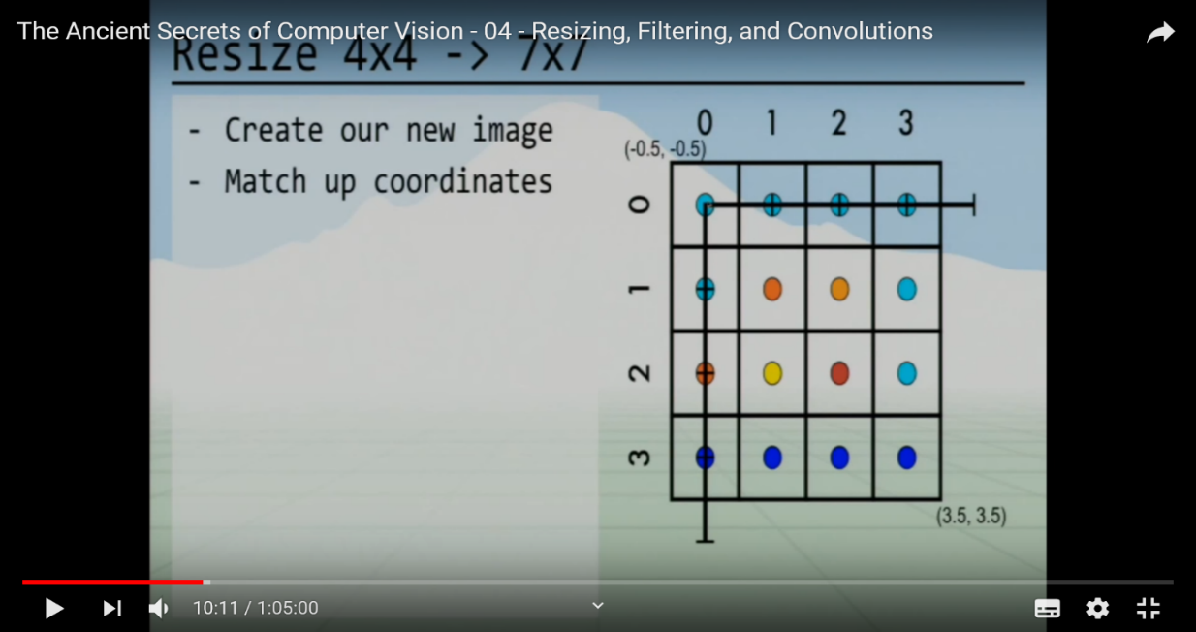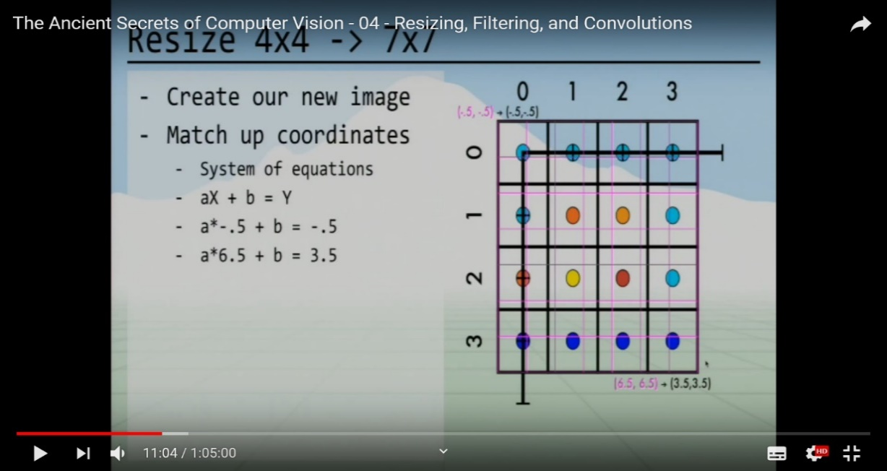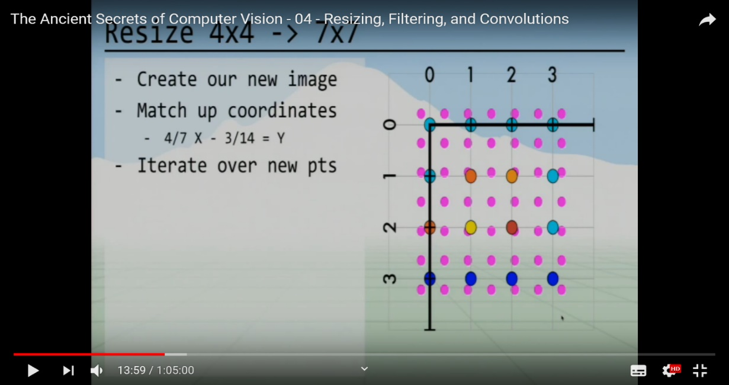

and $a×6.5+b=3.5$

Two equations with two knowns (a and b) are trivial to solve and in this case, it resolves to:

$$\frac{4}{7}×X- \frac{3}{14}=Y$$

Note that the example figure is a square image. For a rectangular image, these calculations will have to be done twice. Once for the horizontal dimension and another time for the vertical dimension.

Intuitively, a type of pixel averaging is the solution for finding the pixel values of a newly resized image. To simplify the problem rather than working on a 2-dimension problem, it is better to imagine a 1-dimension problem.

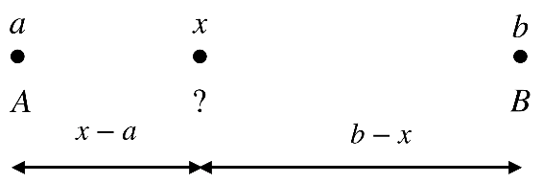

Figure 7: Image of a 1-Dimension array of 2 original points being made into a 1 point. This would be a form of downscaling (making the image smaller).

In the example above the original image has points A and B. A new point X will exist between them in the resized image. To compute the new pixel value at X a weighted average is performed. Where the distance between an original pixel and the new one changes that weight, where those closer to the original pixels carry more weight. The linear equations calculated at the start will provide an equation to translate from the original coordinate system to the new coordinate system. Thus, they can give the position of X in the A, B coordinate system.



Figure 8: Linear Interpolation formula.

The equation above is called linear interpolation. For a 2-dimension image, bilinear interpolation is used instead. This works much the same way but can be broken down into 2 distinct steps.

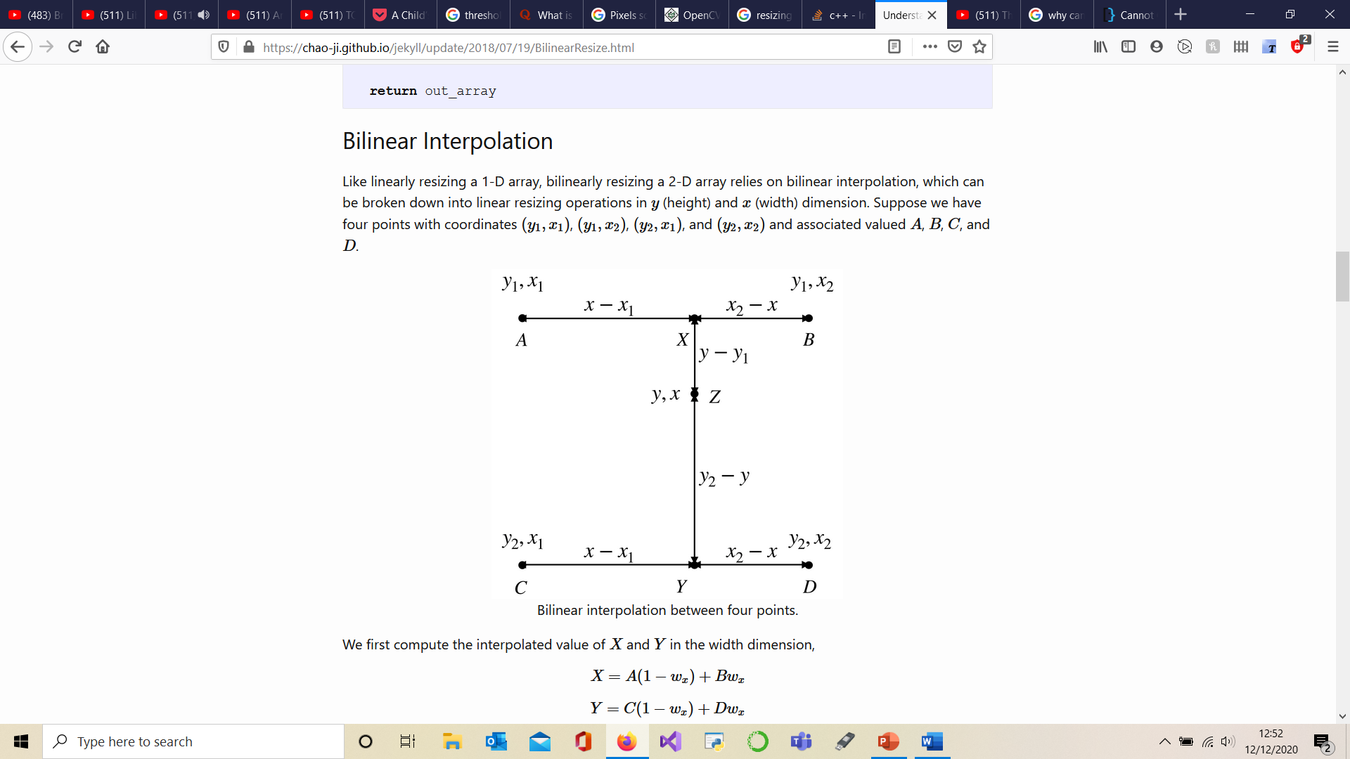

Figure 9: Bilinear interpolation.

In the figure above A, B, C and D make up the original images’ pixels. Z is a resized image pixel value. X and Y are temporary pixels used to calculate Z. Step one is to calculate X and Y pixel values, which is a linear interpolation. Step 2 is to perform an interpolation of Z from X and Y. This is how bilinear interpolation is be performed.

* + 1. ***Convolution***

Convolutions are an exceedingly important part of computer vision. A convolution operation can be viewed as a filter. It works by operating on every pixel in an image and adding the weighted value of the local neighbouring pixels. To finish the operation the addition of the weighted values is divided by the number of local pixels added. This becomes the new value of the convolved pixels.

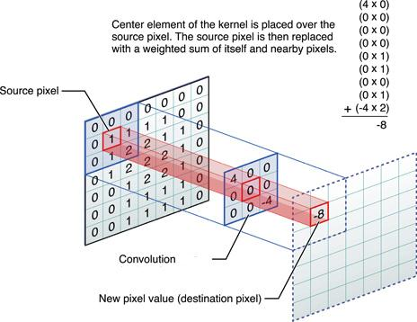

Figure 10: Convolution of the pixel (1,1).

The size of the convolution is called the kernel and is represented by its shape ($A×B$) with A and B both being odd numbers. These typically range from 3 to at most 11. A common convolution operation is to blur an image. This is achieved by averaging the values in a kernel, so the weights in the kernel would all be equal to 1. For a slightly blurred image, a small kernel is used (3 $×3)$ and for a very blurry image, large kernels are used (11 $×11)$. Most blurring operations perform the Gaussian blurring.

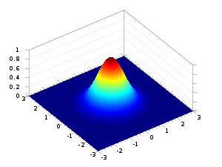

Figure 11: An example of a 3D Gaussian.

Instead of giving equal weight to every local pixel, the pixels closer to the centre have higher weights.

Another important convolution operation is the Sobel filter. This filter can detect the edges in an image. Edges, in this case, relate to a sharp change in colour between two areas of an image. To think of this problem, it is best to imagine a 3 $×3$ patch of an image that is placed along the edge of an image (the edge of a brown tree trunk, with a green field in the background for example). The vertical Sobel filter, also known as vertical Sobel convolution kernel, will return a high value if there is a strong change between the first column and the last column of pixels. This is done by taking the difference between the two columns.

Figure 12: A 3x3 gaussian blur kernel and 5x5 gaussian blur kernel, respectively. The fraction on the side of the kernel represents the factor by which each pixel value is multiplied. The denominator of the fraction is the sum of the weights in its kernel.

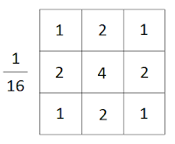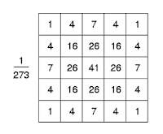

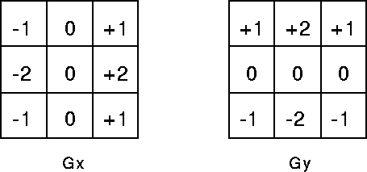

Figure 13: To the left a vertical Sobel filter, to the right a horizontal Sobel filter.

Note how the weights of the kernel add up to equal zero. Naturally, if the 3 $×3$ patch of an image contains the same pixel intensities the kernel will sum to 0, indicating that no vertical edge was detected. The same would occur if a vertical Sobel filter was run on a horizontal edge. Each row would cancel itself out returning zero. Otherwise, a non-zero value is output by the kernel, this absolute value represents the strength of the horizontal rate of change of pixel values in a 3x3 pixel patch of an image. Horizontal filters work much the same way.

The vertical and horizontal Sobel filters can be added together as the convolution operations are linear [3] PAGE 112. This linearity means that an image processed by multiple convolutions can be processed by a single convolution composed of the sum of each convolution’s kernels. Providing other criteria are met, such as the individual convolutions being performed at the same step.

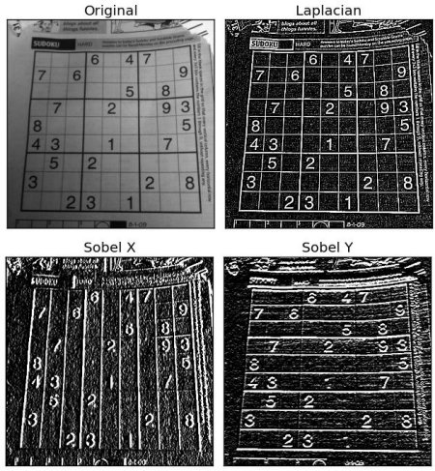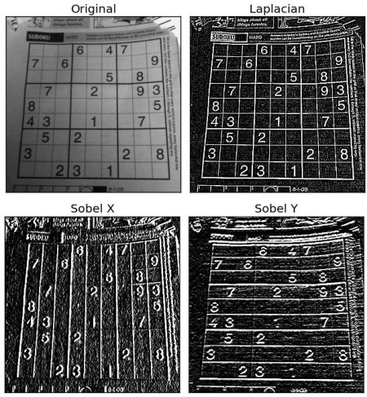

Figure 14: Original image being processed on vertical and horizontal Sobel filters respectively.

* + 1. Canny edge detection

Canny edge detection is a process that extracts the edges of an image. There are a two thresholds (variables) that can be tweaked to change how sensitive the algorithm is to edges. 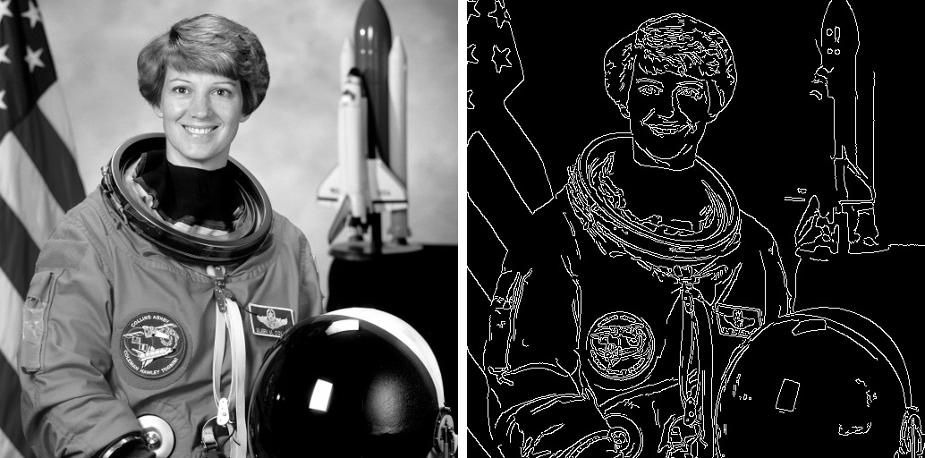

Figure 15: The image on the left is the input image and the image on the right is the output of the Canny edge detector.

The first step in the pipeline is to make the image grayscale (ranges from black and white). The next step is to lightly blur the image. By using a small kernel of size 3 $×3$ for the Gaussian blur operation any “noise” in the image is removed. “Noise” are very small areas of the image which differ from their neighbouring areas. An example would be light peeking through the leaves of a tree. Following the pipeline, a Sobel filter is passed on the image, this operation was explained in the section above called “convolution”. The resulting image is now a grayscale image whose pixel intensities represent the rate of change of the original image pixel values. The last few steps to obtain the canny edges detection pertain firstly in reducing the thickness of the found edges. This reduction leaves them with a thickness of just 1 pixel. Then a thresholding step evaluates each edge as “strong” or “weak”. Strong edges have an average intensity value above the “strong” threshold. This is one of the two parameters that can be tuned in the algorithm. Weak edges have an average value intensity between the “strong” threshold and the “weak” threshold. All edges below the “weak” threshold are discarded. Weak edges that are connected to strong edges are kept; all other weak edges are discarded. The remaining strong and weak edges make up the output image.

* 1. Hough Transforms
     1. Introduction

Hough transforms convert information from a 2-Dimension image format to a Hough Space format. The motivation behind this conversion is the fact that low-level features of an image such as lines and geometric shapes have well defined mathematical properties. Mathematical properties are consistent across all images. Thus, identifying features governed by maths provides a generalised approach to identify low-level features in an image. The Hough transform makes use of the spatial information of an image’s pixels. This is achieved by performing calculations on each pixel of an original picture image, forming a new image called Hough Space. These calculations are then aggregated together under a voting scheme. This voting scheme forms a discrete version of Hough Space whose granularity is typically a little less than the pixel density of the original picture image.

* + 1. Hough Transform

Hough space is a geometric solution for identifying mathematically descriptive features in an image. In geometry, a line is described by two points. In mathematics, any line can be described using two variables, say θ and r in the following equation: y=−cosθsinθ·x+rsinθ [4]. These 2 parameters describe the angle of the line and the height of the line, respectively. Every possible line that passes through a point in space can be mapped by cartesian coordinates with an axis for θ (the angle of the line) and r (the height of the line). This is Hough Space. The result is a curvy line that stretches across from -90° to +90° θ. With each point of the curve representing a unique line. If this Hough space contained the curves of two lines, the two curves should crossover at exactly one point. This stems from the geometric definition of a line being described by two points. An example of what this would look like is shown in the figure below.

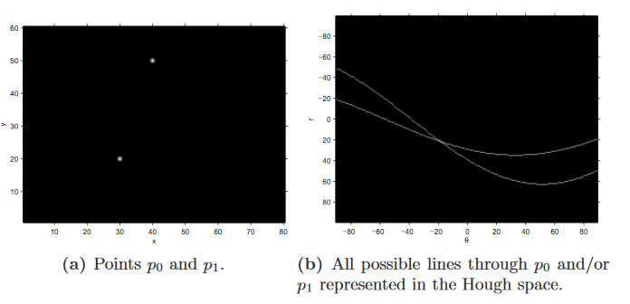

Figure 16: Image on the left of two points in cartesian space. The image on the right represents the Hough line transform of both these points. Note how the curves cross at one unique point between -90 ° θ to +90° θ [4].

The figure below demonstrates how an image of a tilted rectangle is processed by the Hough line transform algorithm. First Canny Edge detection is performed on the original image. This pre-process extracts the edges of the original image. The Hough Line transform algorithm is then run on each pixel of the Edge map. As a result, the curves in the Hough transform space converge at 4 points. Each point represents a line in the original image.

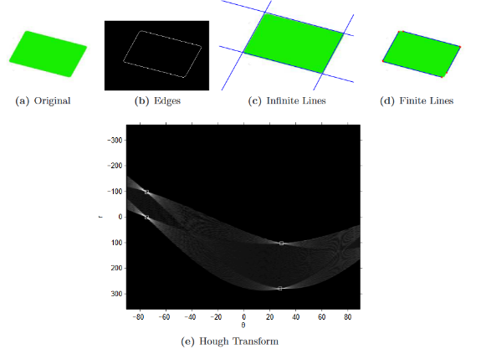

Figure 17: Original image top left, the edge map of the original image, the Hough transform of the edge map [4].

There is a final step for the Hough Line transform algorithm to identify lines in the generated Hough transform space. This is achieved by making the continuous Hough space into a discrete space, called the accumulator. An important step worth appreciating since, in the real-world, edge maps will contain non-line pixels. Thus, Hough space will contain convergences of pixels that are lined up, but which do not pertain to a line in the original image. This would be a false-positive. Furthermore, real-world lines can be distorted when projected into a 2-dimension digital image, making them not quite lines anymore. This will lead to cases where the Hough Line transform of a line of pixels will not all converge at the same point in the Hough Transform space. This is a false-negative. To mitigate both issues the Hough transform Space is split into what is known as the accumulator. Each grid cell of the accumulator logs if a curve either traversed it or not. This means grid cells where a lot of curves have converged will log a higher number. That is how the voting system of the accumulator works. The Hough Transform algorithm will have a parameter defining the number of votes required for a grid cell in the accumulator to be considered a ‘point’ of convergence. This mitigates the false-positive issue. To mitigate the false-negative issue the accumulator density is set to be a little lower than the pixel density of the original image. Such that the number of accumulator cells will be less than the number of image pixels. This provides some leeway for error in the input image. The accumulator density is another parameter that is selected when running the Hough Transform Algorithm.

* + 1. Hough Circle Transform

For a circle, the Hough Space is 3-dimension because the circle is defined by the circle equation who’s 3 variables are the centre (x,y) and radius r. The problem can still be visualised if the r is fixed.

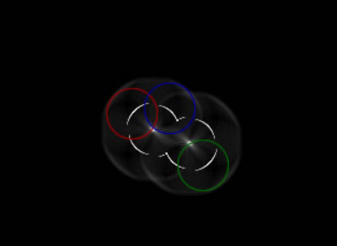

Figure 18: Hough transform for a circle of fixed radius [5].

In figure 18 the white circles represent the real edges. The points comprising a coloured circle are the centres (x, y coordinates) of all potential circles of fixed radius r that a single point of the white circle may be a part of. It can be seen in figure 18 that at the centre of the two white circles there are white blobs. This is, of course, the centre of the actual circle and where all the potential circles converge. The Hough Circle transform works much the same way as Hough Line transform apart from the fact Hough Space is 3-dimension, as a result, the accumulator is also 3-dimension. As such selecting an appropriate accumulator density is trickier. Computation cost is an additional consideration to be made. Hough spaces with higher dimensions take exponentially longer to compute. Hypothetically, a Hough Circle transform takes 0.1s to compute. Hough eclipses transform is computed similarly, apart from the fact it has 2 new dimensions, bringing the total from 3-D to 5-D. Assuming the 2 new dimensions have 100 possible values they can take (height and rotation of the eclipse) and the previous 3 dimensions take the same computation time, then the new computation time will be $0.1×100×100=1000$. The time taken to perform Hough Eclipse Transform is 1000 seconds. Changing the number of values iterated over and the density of the accumulator, has a significant impact on the accuracy and speed of a Hough Transform.

## Feature detection:

* + 1. Introduction

Feature detection is a departure from low-level computer vision. Intermediate level computer vision techniques go beyond operation on pixels by relating one image to other images, the 3D nature of the real world or changes over time in a video, …, etc. Feature matching is a well-established intermediate level computer vision tool. A good example of its application is panorama stitching [5] which relates one image with another. When performing panorama stitching the software must establish how two images connect. Feature matching automatically finds unique points in an image and can match the unique points from two separate images. By aligning two images of a panorama through their unique points, they can be stitched into a single larger image. Panorama stitching can be performed by matching raw pixels patches together, but this low-level approach lacks feature matchings ability to handle such changes between images as image noise, scale invariance, translation invariance and rotation transformations. There are two critical stages in the implementation of this software, as implied by the name Feature Matching: the creation of features which are a set of key points with descriptors, and matching descriptors between images. In the first step, key points are generated, they are pixel coordinates for a small patch of an image that might be unique.

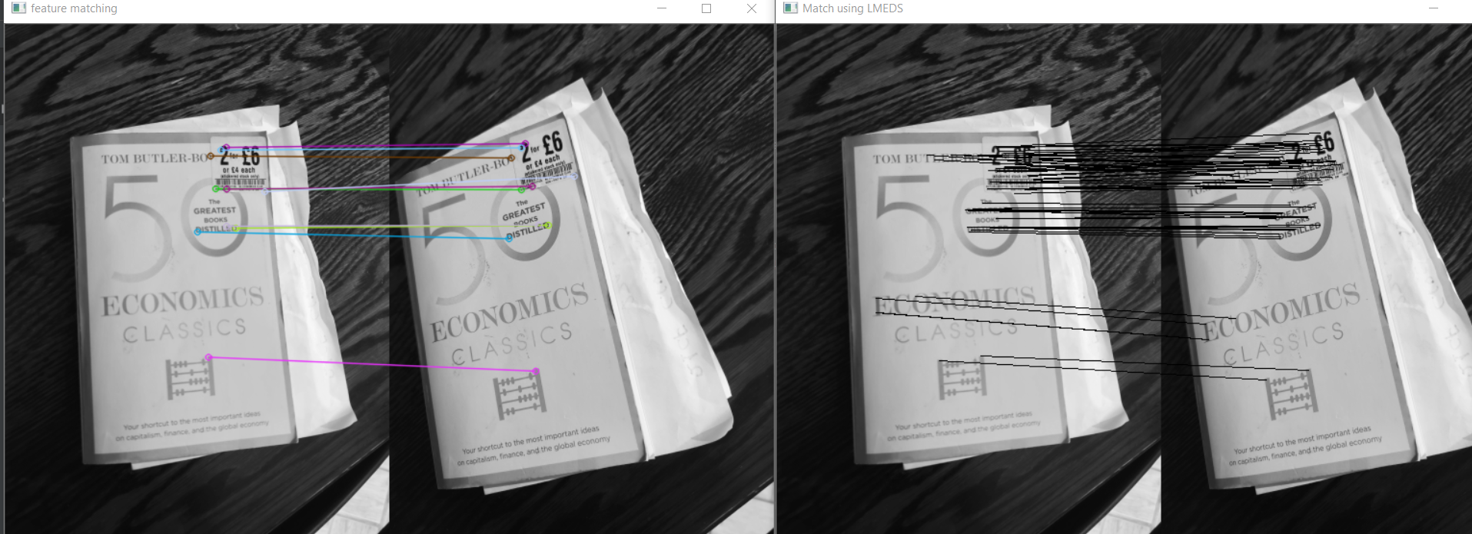

Figure 19: ORB feature matching of two different images of the same book.

To summarise the Feature Matching pipeline:

* 1. Find a set of distinctive key points
  2. Define the region around each key point which will become a key point descriptor. Extract these regions.
  3. Normalise the pixel regions. Normalising takes the pixel values in a region and computes them into a new format that has invariant properties. This means descriptors for the same key point taken in different lighting condition, different distances, …, etc will be the same.
  4. Match the descriptors of two different images.
     1. ***Key points***

The main way key points are found is by using the Harris corner detector or Hessian detector. They both have similar outputs. They find corners in an image because corners are fixed points in the 2-dimension space of an image. To achieve this end, their algorithms will measure the rate of change in pixel intensities over a patch of the image. The presumption is that a strong gradient change in XX and YY (horizontal and vertical axes) or XY and XY (the diagonal axes) indicate a corner. To avoid doing this over the entire image the SIFT (Scale-invariant feature transform) algorithm performs a preparation step. The algorithm performs a difference of Gaussians and different scales. What this means in laymen terms: the image is slightly blurred and then compared with itself. Then the blurred image is subtracted from an even blurrier version of itself. Done recursively enough times at different scales, the output image will only contain areas where potential corners exist and will exist at different scales. Which is an important form making the algorithm scale-invariant. As a small note, the difference of Gaussians algorithms performs an edge detection operation.

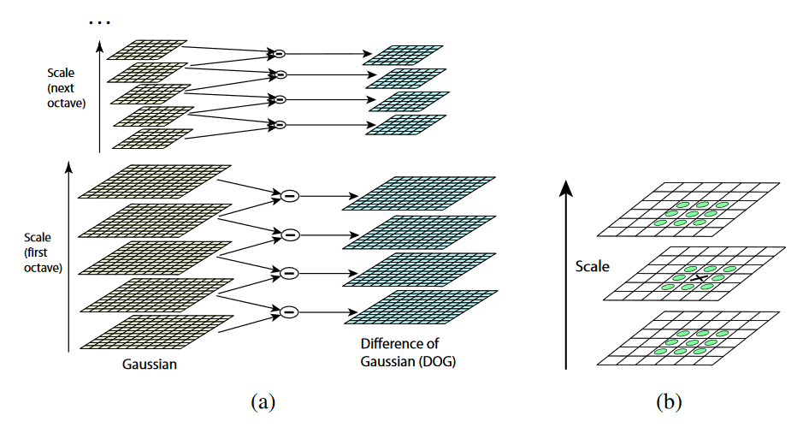

Figure 20: Difference of Gaussians (DoG) [3].

To make sure the key point is unique the pixel region around a key point of an image is compared to itself at different translations. If it truly is unique then it should only have a minimum distance from itself when it is centred.

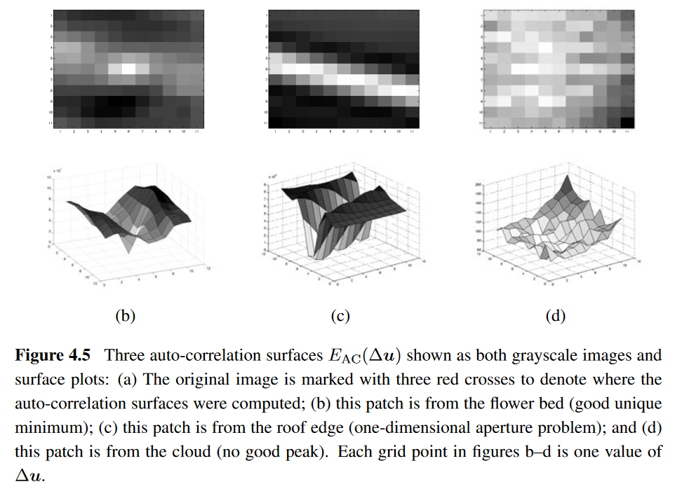

Figure 21: Three auto-correlation surfaces showing both grayscale images and surface plots [3].

The figure above shows 3 examples of an original image and its auto-correlation plot. The plots are computed by iteratively recentring a copy of the original image over each pixel and taking the total difference in pixel values. The very middle of each plot has a distance of zero. This stems from the difference of pixel values of the same image being of course equal to zero. More interesting, the left-most plot is of a corner image. The plot shows the high distance from itself unless it is centred. The other two plots are plots of non-unique key points. This makes intuitive sense as the middle image is a line, so it is only bound in one axis. The right image is a continuous surface, so it is not bound by any axis.

* + 1. Descriptors

Descriptors are then calculated for patches of the image around key points. Before explaining how descriptors are computed it is worth mentioning what a gradient is in this context. A gradient is a rate of change, in computer vision this will often refer to the rate of change in pixels. In the convolution sub-section of the low-level computer vision section, Sobel filters are discussed. These filters are used to find the gradient of a pixel. Key point descriptors make use of Histograms of Gradients (HoG). The idea is to bin together with the gradients of a certain orientation in the patch of the image. Only gradients over a certain threshold are taken. Then the histograms are normalised to the highest bin in the histogram (the bin comprising the sum of the gradients of same orientation in that patch of image). This allows for an apples-to-apples comparison of descriptors. To deal with orientation issues two descriptors are compared with their main orientation (largest binned gradient direction) both pointing in the same direction.

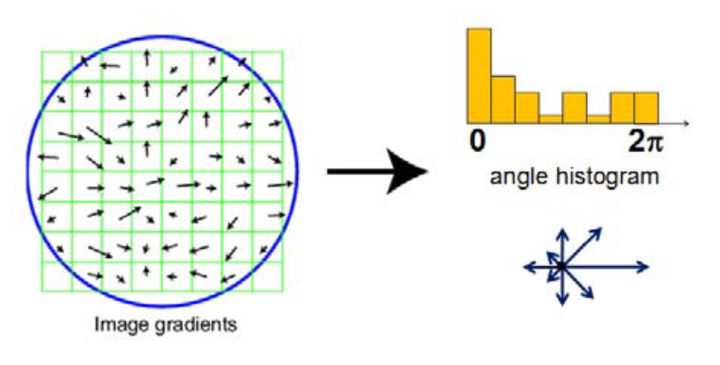

Figure 22: Histogram of gradients for a patch of an image [3].

* + 1. Matching descriptors

The matching of the descriptors can be achieved through brute force. This is where each descriptor of an image A is iteratively compared to each descriptor of an image B. In practice, the work of matching descriptors does not end here because a number of these matches are false-positives. That is to say two descriptors with very high similarity do not always map to the same key point. A common solution is to use RANSAC [6] (Random Sample Conesus) or another similar algorithm.

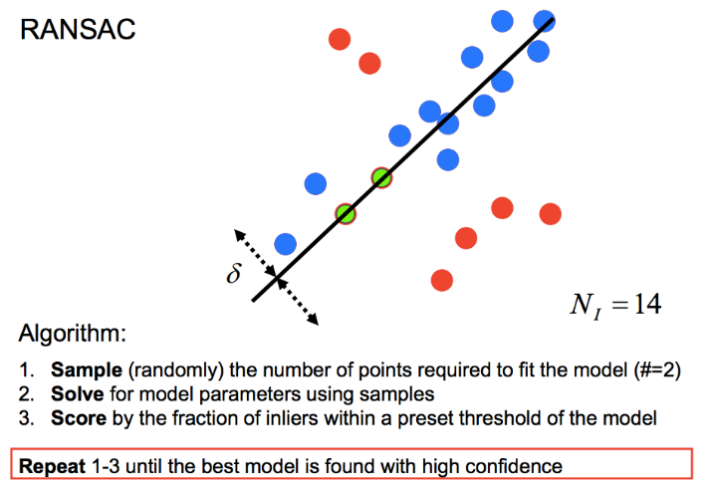

Figure 23: Example of RANSAC used to find the line equation that best fits the data points and algorithm pipeline.

To explain how RANSAC is used it is necessary to understand what a Homography transformation is. An image is captured using a camera from a specific perspective. The perspective describes a distance, orientation, and translation of a camera relative to what is captured in the image. The following is an example used to aide in the explanation: two images A and B of the same object are captured at two different perspectives A and B, respectively. A homography matrix will describe how the pixel content of image A needs to be transformed so it matches that of image B. This homography matrix is therefore akin to describing the transformation of perspective A to perspective B

The following understanding of RANSAC comes from Cyrill Stachniss lecture at the University of Bonn, Germany on SIFT Features and RANSAC [7]. To eliminate the false-positives in a set of matched descriptors the following postulation is made: a small subset of true-positive descriptors pairs will describe key points which are the same in an image A and B. A homography matrix will describe the transformation of the key points in image A such that they are lined up with the key points in image B. This very same homography matrix can be run on the rest of the key points in image A. The transformed key points of image A that line up with key points of image B are true -positives. Those that don’t line up are false-positives. The task asked of RANSAC is to find a small subset of true-positive descriptors, otherwise, the correct homography matrix is incalculable. Thus, a small random sub-sample of descriptors pairs describing key points have their homography matrix computed. If all the descriptor pairs of the small subsample are true-positives, then a correct homography matrix can be computed. All the query image (image A) key points are transformed using said homography matrix. Those that line up with their corresponding key point in the test image (image B) are true-positives.

To improve the speed of RANSAC, it is not the best solution that is found but a solution that’s highly probable to being the best. A fixed number of keypoint pairs are needed to compute a homography matrix, the minimum number of pairs being 4. It is not necessary to test each combination of 4 pairs of the total set of keypoint pairs. Instead, a much lower number of combinations can be tested which will have a very high probability of containing a combination of 4 true-positive pairs. This is possible providing the full set of keypoint pairs contains at least a single combination of 4 true-positives.

Finally, the highest number of key points matches between the query and training images will only occur with a correct homography matrix. This implies that tests with lower match scores generate incorrect homography matrices. As a note, it is possible that the number of matches of the best homography matrix to be ‘low’ in absolute values. In this case, the correct homography matrix was probably impossible to compute. This occurs when two images do not contain the same object. A threshold value is used to measure if enough key points have matched one another to consider the homography matrix to be a correct one. By extension, this threshold is used to decide if a query and train image contains the same object. This is how feature matching is used to match an object in one image with the content of another image.

## Machine learning:

* + 1. Introduction

“Machine learning is a branch of artificial intelligence (AI) focused on building applications that learn from data and improve their accuracy over time without being programmed to do so. In data science, an algorithm is a sequence of statistical processing steps. In machine learning, algorithms are 'trained' to find patterns and features in massive amounts of data to make decisions and predictions based on new data. The better the algorithm, the more accurate the decisions and predictions will become as it processes more data”. [8] The tools developed in machine learning allow the approximation of functions using statistics, data and loss function(s). For example, machine learning can approximate the function $x^{3}$. A machine learning model trained to perform such an approximation would take an input X and output an approximation of $x^{3}$. The approximations’ precision of $x^{3}$ is dependent on the type of model used and how well this model has been trained. Whilst $x^{3}$ is a trivial function to approximate, there exist others which are far more challenging: “What would the function that determines a face in an image look like?”. Theoretically, there exists a perfect function for detecting faces in an image. However, the complexity to find such a function is outside the realms of possibility with current technology. Instead, close approximations are used.

* + 1. How machine space learning is used in computer vision

Machine Learning (ML) can find patterns in data. The type of patterns detected can vary from subtle correlations that would otherwise go unnoticed by human beings, giving software superhuman capabilities. To identify a pattern in the noise of a training dataset, with noise being random data that does not convey any information. This leads to an ML model that underperforms. There are 3 major learning paradigms used in ML to uncover these patterns: Supervised, Unsupervised and Semi-supervised learning. For conciseness only supervised learning is discussed.

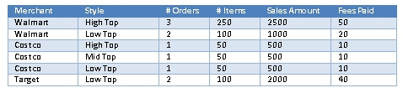

Figure 24: Example of a DATA set. Not that the first row of the table is called a header. This provides the name of each attribute. There is no clear column that is an in this example label.

“Supervised machine learning trains itself on a labelled dataset. That is, the data is labelled with information that the machine learning model is built to determine and that may even be classified in ways the model is supposed to classify data. For example, a computer vision model designed to identify purebred German Shepherd dogs might be trained on a dataset of various labelled dog images” [8]. Before training begins the ML model will be initialised, usually with the parameters/weights set to random values. Changing these weights is how the ML algorithm teaches the ML model. The algorithm will take for input the first entry/row of the training data set also known as an instance. The algorithm computes the data/column values, also known as attributes, to generate an output. This output is then compared to the expected output of the instance also called the label. The “difference” between the two is known as the error and will be used to change the weights and biases in the algorithm, hopefully improving the algorithm's accuracy. The bigger the error the bigger the change. Typically learning in ML is achieved through gradient descent [9].

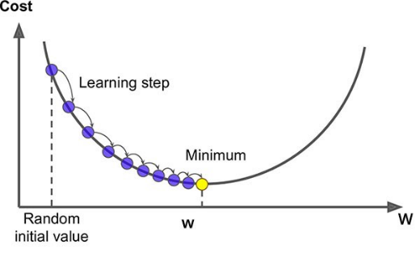

Figure 25: Visualization of gradient descent for an ML algorithm with one weight. The cost represents the error and W represents the value of the one weight.

This is an iterative approach in which the error should get smaller and smaller every iteration until there is nearly no error. When the error rate is acceptable, the algorithm generates an ML model with the appropriate weights. Thus, an ML model is created, which when run in conjunction with the ML algorithm will compute an appropriate output. This is assuming the input is similar to the training dataset instances.

A persistent issue with ML is the trade-off between bias and variance [10]. Bias comes from the assumptions made by the model about the data. For example, a linear model will assume the data is linear, which is bad when it is not. Bias can also be learned from a data set. High bias is often used in simple models. Variance is how sensitive the model is to noise. More complex models are sensitive to noise which translates into models which cannot generalise. Take a model that was trained to identify what the weather will be the next day based on meteorological data. If it overfits the data given during training, which is the opposite of generalising, the model will perform exceptionally at predicting the weather for the next day in the training set. However, it will not perform well in the real world. The better a model can generalise the better it performs on input data that differs strongly from training data. Ideally, low bias and variance can be obtained, but ML models can confuse noise for useful data unless bias is introduced. Inversely a “good bias” is very difficult to find, so most biases found will introduce wrong assumptions into the model. The issue can be partially mitigated by using a lot of good training data in conjunction with other techniques such as data augmentation. Data augmentation creates new data from the training data set, this can remove bias induced by the data collection method.

* + 1. ***Cascade Classifier***
       1. Introduction

The Cascade Classifier was conceived in 2004 by Viola & Jones [11] and gained popularity as it offered real-time face tracking on the consumer level CPU’s of the day “Operating on 384 by 288-pixel images, faces are detected at 15 frames per second on a conventional 700MHz Intel Pentium III” [11]. In other words, object recognition could be performed using very limited hardware resources. Being an object detection algorithm, it outputs a bounding box around an identified object. Potential bounding boxes are generated by running a sliding window across the image at different scales. In essence, this iteratively extracts a region of interest (ROI) from an image by first iterating left to right, then iterating up to down and finally iterating from a large ROI to a small ROI. Each potential bounding box will have the Cascade classifier run on it. How it runs is expanded upon in the next section. Cascade Classifiers is a machine learning approach which differs strongly from how the current state-of-the-art-techniques work and has fallen out of favour due to its issues with a high false-positives rate. With that said, if an object detector is needed for a task that is constrained by hardware speed rather than precisions ($=\frac{True Positive}{True Positive+False Positive}$) then the Cascade Classifier algorithm presents a good solution.

* + - 1. How the cascade classifier detects objects

As the name suggests the algorithm works using a cascade approach. A cascade classifier model is composed of stages, each one being its outright classifier. In the Viola and Jones implementation, the first stage contains the strongest and most unique feature(s) of the searched object. So, with very few features and thus very limited computation the algorithm operates as a good classifier. Subsequent stages are classifiers comprised of less unique features, hence why more of these features must be used together to perform at a similar level to the first stage. “The number of features in the first five stages of the detector is 1, 10, 25, 25 and 50 features respectively.” [11]

To recapitulate, each stage has its classifier. When running the algorithm, a sliding window extracts regions of interest (ROI) from the image. Each ROI outermost pixels will represent a potential bounding box of a sought object. If an ROI isn’t eliminated by any stage of the classifier then the ROI is considered to contain the sought object. Running the classifier in stages provides two key benefits. Each classifier has its own set of weights expressed in the form of different features. It is therefore unlikely that multiple classifiers will be susceptible to letting the same false-positive through. The other benefit stems from the algorithm only looking for the feature(s) one stage at a time. This first stage will deem most of the image to not contain the sought object. What is left are the salient parts of the image which are in turn run through the second stage of the cascade classifier. The outcome is yet more of the image deemed to not contain the sought object. This process is repeated until only the matching parts of the image are left. By cascading the overall classifier objects can be identified without using too many computation cycles: “Computation of the two-feature classifier amounts to about 60 microprocessor instructions. It seems hard to imagine that any simpler filter could achieve higher rejection rates. By comparison, scanning a simple image template, or a single layer perceptron would require at least 20 times as many operations per sub-window” [11]. A single layer perceptron is a very basic form of neural network. Neural networks are an integral part of most computer vision techniques today, so it is worth noting the difference in computational demand.

In the case of the facial recognition proposed in the paper by Viola & Jones, the model evaluated around 6000 features in 38 layers. The algorithm needs to prioritise the classifier with the smallest set of features(s) first as this is the quickest to compute. This cascade approach is 1 of 3 factors that make this classifier fast to compute. The other 2 factors stem from the choice of features and the mathematical shortcut that speeds up their calculation. The set of possible features are a set of rectangles each containing sub rectangles than can be dark or light. Naturally, an image must first be gray scaled before computed by the Cascade Classifier algorithm.

Figure 26: (Left) the two features are used in the first layer of the cascade classifier face detection model trained by Viola & Jones. (Right) examples of 4 different features that can be used by the Cascade Classifier Algorithm [12].



To improve the speed features are calculated. A pre-processing step calculates the average intensity of the contained pixels in every possible rectangle ROI connected to the top left corner of the original image. This is an operation which iterates over each pixel of the image to form each possible rectangle. As a result, each pixel of a new image contains a value representing the average pixel intensity of the rectangle constrain in (0,0) at the top left and (pixel coordinates) for the bottom right.

* + - 1. Key issues with object detection

There is an issue with false-positives as can be seen in the results below.



Figure 27: Performance of the Cascade Classifier relative to other object detection algorithms [12].

As the recall goes up (high true-positives rate, and low false-negative rate) precision goes down (high false-positive rate). Whilst the cascade classifier proposed by Viola and Jones is incredibly fast it might not have sufficient accuracy for real-world application. To avoid creating too many false-positives Viola and Jones used a voting system present in the results table above. Three differently trained cascade classifiers would vote on whether or not a bounding box contains a specified object. The results are still somewhat insufficient but running post-processing on the proposal regions created. A cascade classifier to eliminate false-positives remains a feasible option for obtaining fast object detection.

Other key issues include the bounding boxes being square. As a result, they inaccurately bound non-square objects. The last issue pertains to the nature of object detection. An object detector model can detect multiple objects (multi-class detector) or detect only one object. Each cascade classifier model can only identify a single object, making it impractical to identify more than a few objects at a time.

* + 1. Convolutional Neural Network (CNN)
       1. Introduction

Convolutional Neural Networks are now the conventional way image classification is performed. In image classification, the goal is to output the label of the image. An image of a dog will be classed/labelled as a dog by an appropriate CNN model, even if the dog is not centred in the image. Object detection is slightly more challenging as it requires the algorithm to correctly identify the location of the object. Additionally, multiple objects can exist in one image. The pipeline for object detection with CNN takes two steps. The first step is the identification of bounding boxes where an object ‘might’ be located. The second step runs the CNN on a patch of an image inside a potential bounding box. If a label is confidently output by the CNN algorithm, then the bounding box appears on the resulting image with the label name and a confidence percentage if available. This approach comes under machine learning and as such requires the training of a model. Some of the most advanced CNN object detector algorithms have taken a holistic approach. That is to say, the bounding box detection and CNN are run together rather than separately. This end to end approach is possible because bounding box detection can be done using a neural network and the benefit is a system that is easier to train and can run quicker. The YOLO object detection algorithm is one such holistic approach. [12]

* + - 1. Artificial Neural Networks

Neural networks (NN) are a form of biologically inspired software. [13] Even simplistic animals can interpret the world around them using their brains. The way brains perform cognition is still under investigation. It is understood that an external stimulus can trigger neurons. When enough electrical signal is received by a neuron, that neuron, in turn, releases an electrical impulse to all the neurons it is connected too. Looking at a basic feed-forward neural network the network is composed of layers of neurons.

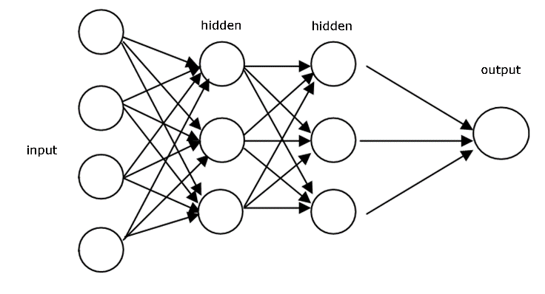

Figure 28: Example of a feed-forward Artificial Neural Network. The circles are the neurons, and the arrows are the connections and direction of stimulation.

Each neuron is connected to every neuron of the prior and subsequent layer. The neuron endings that form the first neurons will trigger when sufficient stimulus is given. This stimulus will cascade throughout the network of neurons moving layer to layer until it reaches the output layer. In a biological brain, this could be a muscle. In a computer, this could be the label of an input image. In summary, the network has an input layer of neurons, processing layer(s) of neurons that are interconnected and an output layer of neurons.

Artificial Neural network (ANN) algorithms like other forms of machine learning algorithms approximate functions. Models differ from one another by tweaking 2 types of parameters: how much stimulus does a neuron need to trigger (send stimulation to the neurons it’s connected to) and how strong is the connection between two connected neurons. The latter is where most of the learning occurs during training. Models differ from one another through their architecture as well. An ANN architecture is described by the number of layers, how many neurons per layer and how each neuron is connected to one another. This is generally not modified during training. In practice, artificial neural networks have a particular architecture which looks as follows:

* An Artificial Neural Network has an input layer, which is followed by at least one connected layer and finishes with an output layer. The number of neurons depends on the input type. Take a network that measures the probability of rain, if the data available is air pressure and air humidity, then 2 neurons are used as inputs. The number of neurons on the output layer depends on the output required. Continuing with the rain example, a single output neuron is used to return a number between 0 and 1 representing the probability of rain. In between the input and output are the hidden layers of the network. The quantity of neurons here is somewhat arbitrary and task dependant. It can also vary from layer to layer. Typically, the first layers have more neurons than the later layers.
* The way these neurons are connected is important. It is common in a feed-forward ANN for all the connections in layer **n** to connect to neurons in layer **n+1**. This type of connection is called a dense connection. Other methods are possible and are one of the distinctive features of Convolutional Neural Networks which are discussed later.
* A neuron is only triggered when the sum of its inputs is sufficiently high. This threshold can be unique to each neuron but in most cases it is not. The strength of the neuron output is proportional to the strength of the input. This threshold for triggering a neuron is determined by an activation function. This function serves a secondary purpose as it normalises the input/output signal between 0 and 1. Networks can also operate with a range of -1 to 1 if the activation function is suited for it.
* The connections between the neurons are known as weights and can possess different floating-point values. This is where most if not all the learning occurs in ANNs. The floating-point value is the coefficient the output of a neuron from layer **n** will be multiplied by before being added to the sum of the total inputs of a neuron at layer **n+1**.

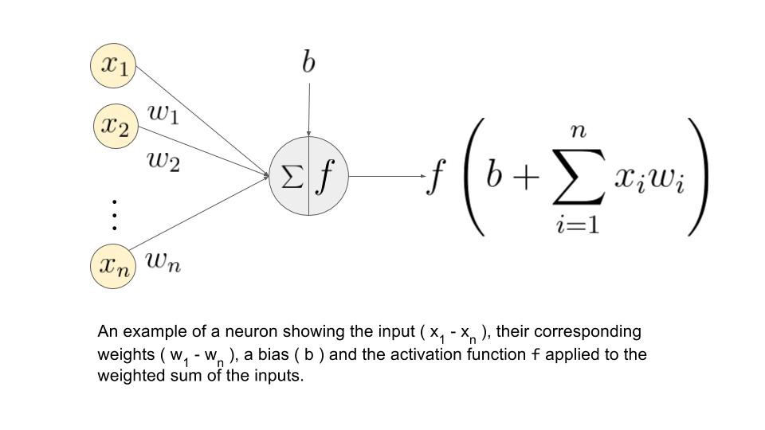

Figure 29: example of a neuron showing the in input (x1-xn), their corresponding weights (w1-wn), a bias (b) and the activation function f applied to the weighted sum of the inputs.

The feed-forward multilayer neural network architecture has been heavily studied and it has been found that it can approximate any function [14]. Finding an algorithm to train a multilayer neural network proved to be a colossal task and was developed by Paul Werbos in 1974, David Parker in 1982, LeCun in 1984, Rumelhart, Hinton, and Williams in 1986 [13]. For conciseness, the way errors are backwards propagated through a multilayer fully connected neural network will not be discussed.

* + - 1. Convolutional Neural Network

The precursor to the Convolutional Neural Network (CNN) is the multiplayer neural network. Kunihiko Fukushima developed an architecture inspired by advances in biology that contain the 2 major components of a CNN: convolution layers and pooling. Convolutions act as filters, on a raw image this can extract lines, corners and colours. The pooling step downsizes the data output by the convolution layer, so the computation is much faster and helps the algorithm ignore irrelevant data. The paper “Backpropagation applied to handwritten zip code recognition” [15] is often cited for being the first true CNN. As the title implies the CNN was used to identify images of handwritten digits and backpropagation was used to train the network. The most notable achievement in this project comes from the CNN ability to train directly on raw image pixel values after the digits are extracted and resized to 16x16 pixels. The hardware limitations of late 20th century slowed the progress of CNN development until the 2000s with “ImageNet classification with deep convolutional neural networks” [16]. This is usually cited as the first contemporary CNN and was the winner LSVRC-2012 competition. The challenge was to perform image classification on a data set containing potentially 1000 different classes. At the time AlexNet (name of the CNN) beat the nearest competition by an error difference of 11% on the top-5 best matches. This achievement was possible due to advances in GPU hardware, the availability of large data sets such as ImageNet which contains 1.2 million images of 1000 different classes and the teams’ efficient integration of the GPU hardware into the CNN training. GPU’s are important for CNN’s as a lot of the computations are matrix multiplications and GPUs are efficient at performing matrix multiplication.

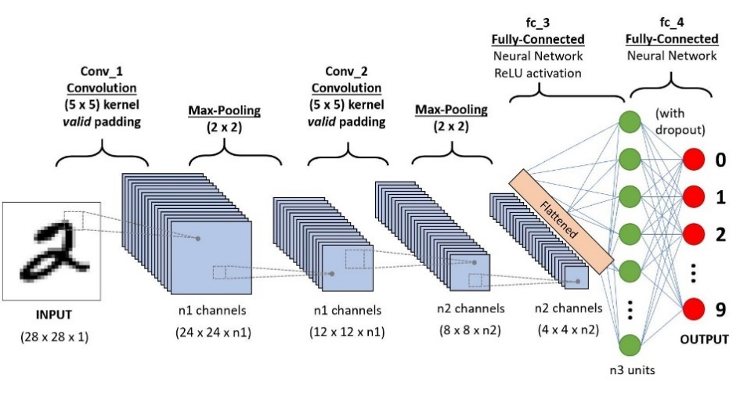

Figure 30: Example of conventional CNN.

The figure above shows a typical CNN. The convolution operation is discussed in greater detail in the “Low-level computer vision” section but to summarise, convolutions act as filters and act on a local area around a pixel. This gives them the ability to extract features from an image and keep their spatial information. Multiple convolution operations are performed on input data. This comprised the convolution layer. Having a large number of convolutions computed generates an exponentially large amount of data as multiple output “images” are created. To mitigate this growth in data, convolutions that would overlap the edge of the input image are not performed. This reduces the output image size slightly. The stride of the convolution can be increased so some pixels are skipped. This reduces output size substantially.

Lastly, the pooling layers purpose is to reduce the size of the convolution outputs. This is often achieved by having a 2x2 pooling kernel slide across input “image” and select the strongest “pixel” in each 2x2 “image” patch to be added to the output image. This is also called max pooling. In each pooling step, some spatial information in the network is lost but this is a worthwhile trade for the speed up it provides. The term “pixel” is used because the output of each Convolution and Pooling layer is a set of “images”. However, the meaning of these “images” and “pixels” has no direct connection with the original image or what a human considers an image to be. Inside the CNN the outputs of Convolution and Pooling layers are features extracted from the image. The deeper into the network the more abstract these outputs become. These features of features are also called higher-level features. The highest-level features are generated after the second max-pooling layer in the CNN example of Figure 30 above. The “pixels” of the highest-level features are then flattened. This term means the numerous 2-dimensional “images” are transformed into a single array. This flattened array, in turn, becomes the input layer of a couple of dense layers. The spatial information no longer matters so the order or the “pixels” in the flattened array no longer matter so long as it remains consistent across runs of the CNN. The dense layers which act just like a regular NN make sense of the high-level features extracted. The number of nodes in the final output layer will correspond to the number of classes the CNN model is meant to classify.

* + - 1. Transfer learning and Training of CNN

A notable issue with CNN is how challenging they can be to train; especially if they are made up of many layers. Before moving on it’s worth noting that the number of convolutions performed at each convolution layer is fixed. The types of convolution performed are learned during training. The convolutions performed in the first Convolution layer will identify low-level features. It is likely filters such as the Sobel Filters will be automatically generated to find edges in the image. From a conceptual perspective, the CNN is trained the same way as a regular ANN. A backpropagation algorithm changes the weights of the CNN at every training epoch. The backpropagation algorithm tries to enact greater change to weights that contributed more to the error in classification. However, this is ambiguous for layers that are far from the output layer. Thus, backpropagation works worse for deep CNNs.

Research into better backpropagations and workarounds is currently taking place. GoogleNet developed by google has multiple outputs throughout the CNN. The assumption is that even 1/3 of the way down a deep CNN a reasonable classification of the input image should be possible. During training, these outputs will backpropagate an error which is local to the nearby prior weights and thus more relevant.

Alternatively, if a CNN image classifying model performs well it is possible to reuse its first layers in other image classification problems. This mitigates the need to train the early layers. This stems from the fact the first layers in a CNN are not model specific. All images possess the same low-level features. This type of CNN model training is called transfer learning. Two approaches are possible.

1. The Input to N-hidden layers of the CNN is “frozen”. This means the backpropagation doesn’t update the parameters of these layers. The other layers N+1-hidden to output layers parameters are randomised. It is also possible to modify the architecture of CNN after the N-hidden layer.
2. The Input to N-hidden layers of the CNN is “frozen”. The raw output of the N-hidden layer is flattened and fed into a different Machine Learning (ML) algorithm to train. Image data is non-linear, so the ML algorithm must function on none linear data. A logistic regression model can be used for this approach to transfer learning.

In either case, the dense layer of the CNN must be retrained or removed, and the new model output is adapted to the number of classes in the new data set.

# Low-level computer vision experimentation

## Introduction

Low-level computer vision techniques act upon the pixels of an image. This contrasts with intermediate-level and high-level computer vision techniques which interpretate the pixel content and how it can relate to something else: other images, objects in an image or the evolution of a video overtime. The main attraction of Low-level computer vision techniques is their computed speed. It was hopped that the relatively unique circular feature of car wheels could be leveraged to identify them. Low-level computer vision algorithms are sensitive to any changes in scale, orientation, position, lighting, and obstruction. Additionally, all the rules to identity the car wheel had to be coded by hand, which can be challenging when the object being detected can come in different versions. The experimentation performed took place on different car wheels with orientation and scale being roughly the same. Even in this ideal situation there were some significant challenges which led to the abandonment of this approach for car wheel detection. That said the Hough circle transforms showed promise for identifying the hub cap of car wheels.

## Edge detection and contour matching

* + 1. ***Introduction***

To find information in an image the software must understand what pixels or regions of pixels are important. The type of problem being tackled will shape how this is achieved. Ideally, the car wheel would be very distinct in its environment. That way some rule(s) could be used to distinguish it from the rest of the image. Unfortunately, the colour pallet of a wheel does not provide any favours as it is gray/black as is the ground and the space between the wheel and the wheel arch. During experimentation close and well-lit images of car wheels were used. This ideal scenario represents the proof of concept. Unfortunately, the results were too disappointing to carry on further investigation of an edge detection and contour matching algorithm. For the task of lug nut/bolt identification, edge detection and contour matching could be a viable choice.

* + 1. Brief code structure

Wheels have a 1-1 ratio between their height and width in frontal view. This piece of knowledge is used to simplify the problem when testing the potential of edge detection and contour matching. In the experiment the code looks for the largest contour (edge of closed shape) that has a 1-1 ratio.

A common method in computer vision is to downscale, grayscale and blur the image. Downscaling and grayscaling reduces the complexity of an image and the blurring removes high-frequency noise. The next step is to apply canny edge detection to the resulting image. After obtaining the Canny Edge image, the algorithm searches for the image contours. These contours enclose a shape whose sides are made from the edges in the image. The contour identifying algorithm performs some guess work to connect gaps in the edges. This allows for a non-perfect Canny Edge images to be usable.

The images used during testing are all close ups of car wheels, this again simplifies the problem. The contours are then ordered from largest to smallest. This list is run through a loop which checks for the first contour with a roughly 1-1 ratio in height and width. In the ideal setup the largest contour presenting a 1-1 ratio in height and width in this experiment would be the car wheel.

* + 1. Results

The edge detection failed to perform consistently. When it did work it was almost always finding the hub cap of a car wheel, which is not a major issue but highlights the difficulty for low-level computer vision to decern the car tires form their background.

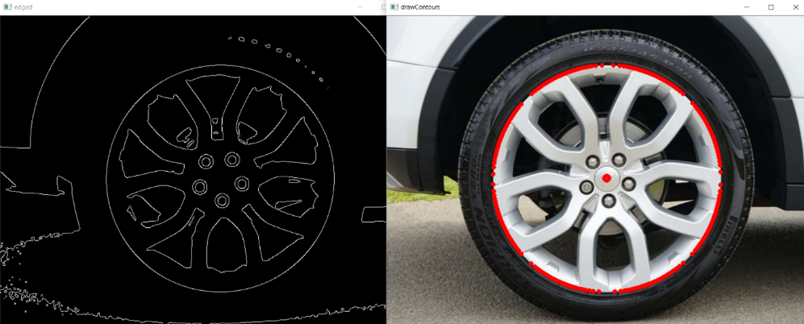

Figure 31: Left is the edge detection; right is the hubcap contour boundary and centre.

This is not a surprise given that Edge Detection struggles to identify an edge between similar colour shades. This issue is clear to see in the figure above. For the ideal dataset used in the experiment, fine tuning can be performed to enable the algorithm to work very well on a single image.

* + 1. Conclusion

Whilst this technique is not suitable for car wheel detection, it could be a solution for detection of car wheel bolts/lug nuts. This is because the car wheel bolts can be viewed in a much more controlled environment. With further work it could be possible to automatically fine tune the image to eliminate inconsistent lighting conditions [18]. For full car wheel detection issues in lighting, scale and orientation make the development of an edge detection and contour matching algorithm incredibly challenging. Thus, the idea of using Edge detection and contour matching was abandoned.

## Hough Transform:

* + 1. ***Introduction***

The Hough transform of an image is a manipulation of an images pixels that considers the mathematical description of a shape. In the case of Hough circle transform the searched shape is a circle. An immediate concern of the Hough transform is the time taken to process a single image. The time to process is dependent on the search space. A circle in this case has 3 parameters making it a 3-dimension search space, with every dimension multiplying the time complexity of the algorithm. Simplification of the problem is possible by limiting the range of values the parameters can have. During the experimentation, the Hough circle transform was used on images of car wheels that were close, well-lit and facing the camera. This is the simplest situation possible. Unfortunately, the Hough circle transform encountered the same issue as the Edge detection and contour matching experiment. The Edge detection is too inconsistent from image to image; thus, the circle detection is inconsistent as well.

* + 1. Brief code structure

Open CV has a prebuilt function for performing Hough circle transforms. Most of the experimentation was spent testing different parameters for the function.



Figure 32: OpenCV HoughCircles method official documentation.

There is an in-built Canny Edge detector in the function. The image to be fed to the function needs to be grayscale and should be slightly blurred. The parameters tuned primarily were those of the Canny Edge detector. These proved to be problematic for the Hough Circle detection as this directly impacted performance from accuracy and computation speed perspectives. Multiple circles were detected in the image. To select the correct one during experimentation the code selects the largest of the circles. This of course wouldn’t be possible if the car wheels were further away from the camera.

* + 1. Results

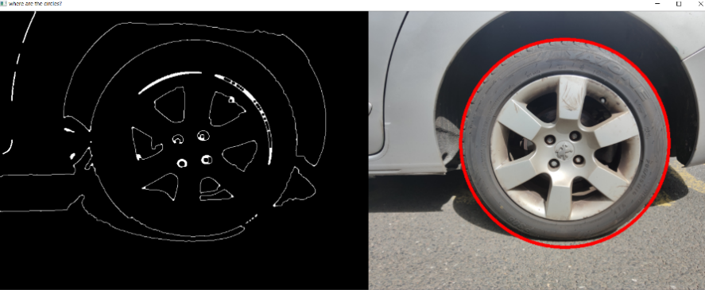

Figure 33: Example of successful Hough Circle Detection on car wheel.

With some tuning, parameters outlining a car wheel correctly could be found for an individual image. When the edge detection performs well so does the Hough Circle Detection.

The figure 34 below shows the results of different car wheel images processed with the same Hough circle detection parameters as in the successful example. These images were captured on the same device, at about the same time of day and location. Thus, lighting only differs slightly. This exemplifies the difficulty in getting Hough transforms to work in a real-world condition.

It was hoped Hough circles transform could compensate for poor edge detections by leveraging the mathematical properties of a circle. The first 2 examples of figure 34 highlight that this has limits. Between this problem and the time complexity involved with running a Hough Eclipse transform this approach was abandoned for car wheel detection.

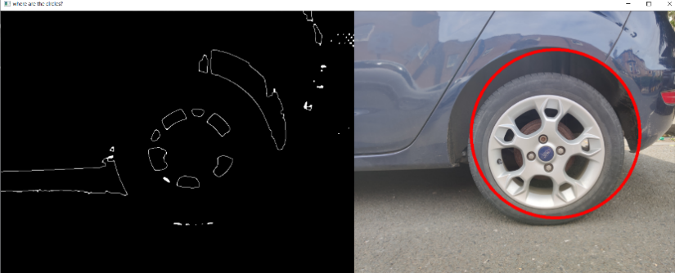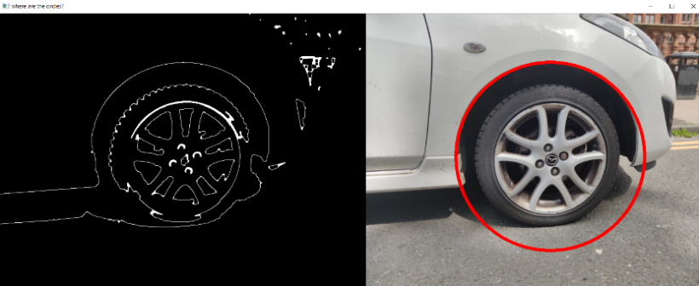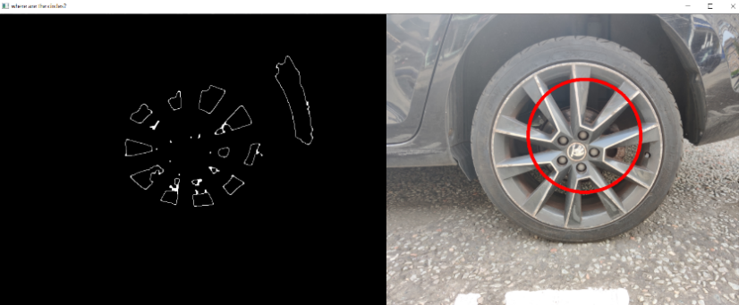

Figure 34: Examples of Hough Circle Detection failures on car wheel images.

* + 1. Conclusion

Hough Circle Detection can be used to find the outline of a car wheel once the robot has navigated in front of a found car wheel. This would not be computationally expensive as approximations of the circle parameters would already be known. Whilst providing provides exact boundaries of the car wheel it would also provide a last validation step to avoid false-positives. This is best developed once a robot prototype is made, as to best fine tune the parameters based on real world applications.

For a full car wheel detection system, the Hough eclipse transform which has a 5-dimension search space would have to be used. Using this algorithm would defeat the purpose of using low-level computer vision as it takes vastly too long to compute. The effort to make this functional isn’t worthwhile when other computer vision techniques exist.

# Intermediate level computer vision experimentation

## Summary

Intermediate level computer vision techniques are responsible for relating an image with another entity. During this section of the project Feature detection and matching was experimented with. The goal of these sets of algorithms is to relate the content of one image with the content of another image. If the content is ‘similar’ then it is assumed both images share the same content. The Random Sample Consensus (RANSAC) in conjunction with a tool to find the Homography Matrix relating image perspectives takes this a step further. The result is an algorithm that can match the contents of two images. There are certain limitations to this method, however it is still used within the working implementation of this project’s car wheel detection software. It is not used as a tool to identify car wheels but as a tool to track bounding boxes. Its use in the wider car wheel detection project is elaborated on in the “Working Implementation” chapter.

## Feature detection and matching

* + 1. ***Introduction***

Feature detection is a tried-and-true method in computer vision, additionally it is invariant to changes in illumination, orientation and scale. An important takeaway from the research and implementation conducted is that feature detection does not work well on every kind of object and does not generalise. In theory it shouldn’t work with car wheels as they have no unique “key point”. The existing key points are part of the hubcap, which differs for car wheel models. In short, car wheels possess no “unique features”. In practice its unique features are noise on the car wheel image. This is sufficient to usually distinguish one car wheel from other car wheel and background scenery.

Feature matching is heavily used in the final implementation. Rather than be used as an object detector it’s used in bounding box tracking. Once a car wheel has been detected in a video feed, the car wheel’s patch of image has its features extracted. This allows subsequent frames to use feature matching. By bypassing the car wheel detection, the algorithm runs faster, and the algorithm can distinguish car wheels from one another. Providing a unique ID to each car wheel identified.

* + 1. Making features and matching them

A typical feature matching pipeline looks as follows:

1. Find a set of distinctive key points in two images
2. Define region around each key point which has invariant properties (ex: scale, orientation)
3. Extract and normalise the region content
4. Compute descriptor from normalised region
5. Match the descriptors from the two images

The code developed looks as follows

1. Initialize feature detector object: ORB (SIFT, SURF exist, as well, but are patented)
2. Then the object takes an image as an argument and computes the key points and descriptors of said image. Perform this on both train and query images.
3. Create a match object to match the descriptors of the train and query images. A brute force technique that measures how a descriptor from one image differs from the descriptor of another image, generating descriptor pairs.
4. Use RANSAC (or similar algorithm) to eliminate false-positive pairs of descriptors, the unmatched pairs of descriptors. The homography matrices of random sets of 4 descriptor pairs is computed until the best homography matrix is found. The “Theory” chapter explains it extensively. The number of key points that are transformed from the train to query using the best homography matrix provides a matrix to measure how well two images match. This metric is used to threshold if the two images match.

The ability to quantify the distances between descriptors led to a non-working initial feature matching implementation, hence the necessity of 4th step. The idea was to sum the distance of the top matches and set a maximum threshold for which a matching pair of train and query images had to be below. After much experimenting the reasons for malfunctioning were clear. Firstly, two very similar descriptors can describe two different key points (false-positives). Secondly, car wheels do not possess good unique features. So, it’s possible for matching key-points to have descriptors that don’t match as their descriptors aren’t very specific and can match a number of other key-points better (false-negative). As a result, the distance metric stayed around the same value no matter what images were being compared, unless an image was matched against itself in which case the distance was 0. Thus, a second implementation using RANSAC was coded.

* + 1. Use in final implementation

Feature matching is used to optimise the speed of the final implementation. Given that the final implementation can only check a single patch of image for a car wheel using the Convolutional Neural Network once per second, it makes sense to bypass the CNN when possible. The bypassing is achieved through custom bounding box tracking code for which ORB feature matching is an integral part. Once a patch of image is confirmed to be a car wheel by the CNN, the image patch ORB features (key points and descriptors) are added to a new car wheel object (in programming terms) which in turn is added to a dictionary of known car wheels. Once added to the dictionary of known car wheel objects a car wheel can be tracked.

The bounding box tracking will first check if a bounding box at frame f lines up well with a bounding box of a car wheel at frame f-1. If this is not the case, then the software can’t confidently assume any nearby bounding box is the car wheel. Thus, ORB feature matching checks if the features of the bounding box at frame f matches the content of a car wheel bounding box at a prior frame f-n.(need to explain n )

* + 1. Results

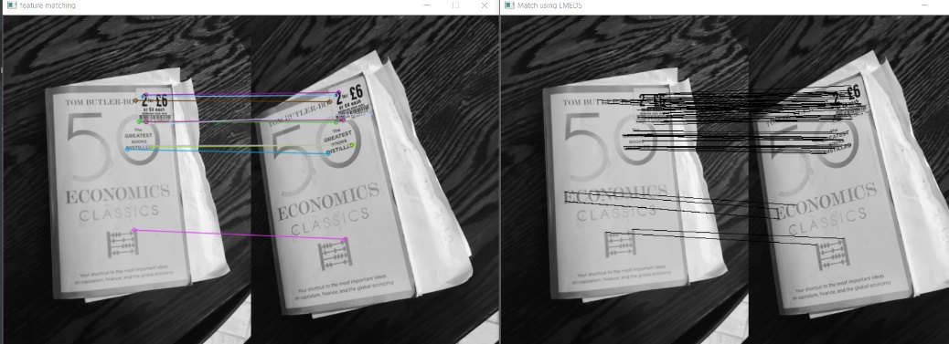

Figure 35: (left) The best descriptor pairs key-points, (right) the matches that line up for the best homography matrix. The number of matches on the right show this is a good match.

In the above case the two similar images have very distinct key points. This is evident because the best descriptors pairs on the left are all true-positives. The lines that connect the query and train image match the same key points. Therefore, on the right side RANSAC found an excellent homography matrix which correctly fits many training image key points to the query image key point.

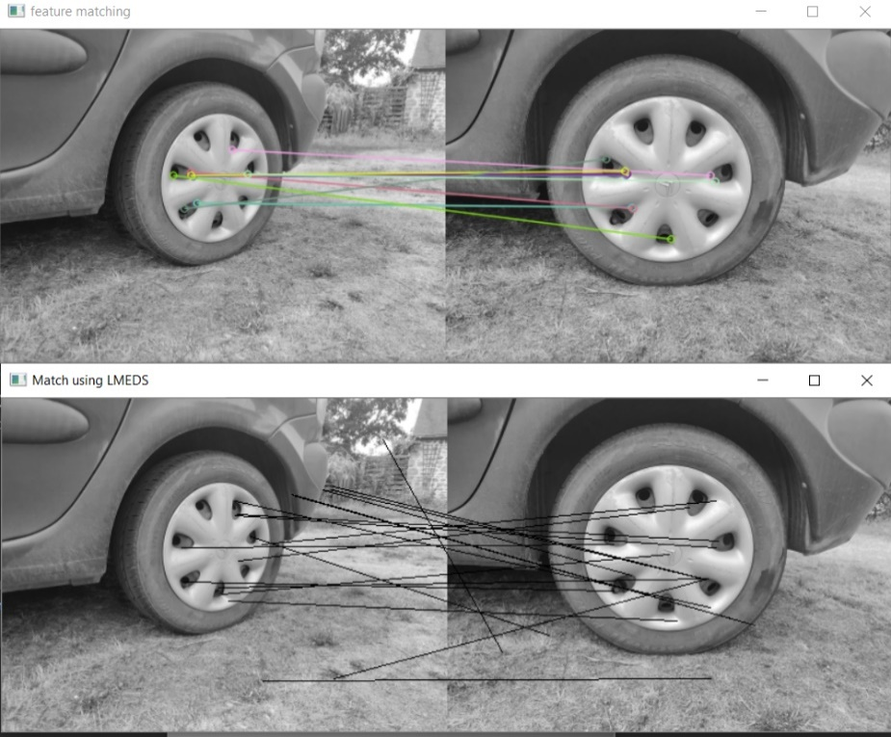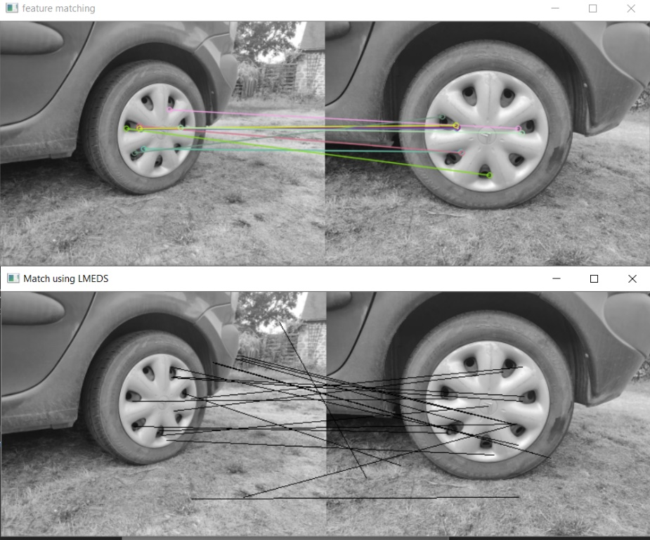

Figure 36: (top) The best descriptor pairs key-points, (bottom) is the matches that line up for the homography matrix. The number of matches on the bottom show this is a bad match.

The above image describes a case where the key points are not very descriptive. Looking at the descriptor pairs it is clear some of them are false-positives. The pink line is an example of a false-positive descriptors match. The line stretches from the 1 o’clock position hole on the hub cap to the 2 o’clock position hole. Given that these are the best matches of descriptors from the train and query images it is safe to presume that the rest of the descriptors are poor matches. This is not a surprise given that car wheels have no corners besides on a few hub caps. The hub cap has a repeating motif so what key points are found are not unique points. The descriptors in the same image are similar to one another. Unsurprisingly the homography transformation of the training image into the query image returns nothing distinguishable.

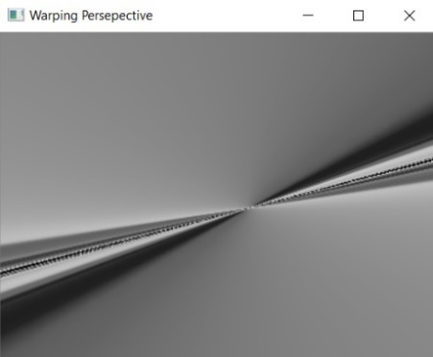

Figure 37: Transformed image of the car wheels of figure 36. The best homography matrix generated with RANSAC is used to transform the image.

Further experimentation showed that when a car wheel image’s ORB features are matched to those of a non-car wheel a homography matrix was never found. If on the occasion one was found the number of matches would be exceedingly small.

When comparing the ORB features of two images of the same wheel the results are erratic. This is probably due to the key points being weak. So, they are not always consistent from image to image.

When comparing the ORB features of two wheels there is often a weak match. To help compensate for this, in the final car wheel detection code the ORB features of the car wheel and the area around the car wheel are used, this has brought no noticeable improvement though.

As a result, a high threshold for ORB feature matching is used when the code exhaustively checks each known car wheel on a bounding box patch of image. This type of test is necessary when the bounding box tracking has completely lost track of a car wheel. A medium threshold for ORB feature matching is needed when a current bounding box is near a past bounding box of a car wheel, but not similar enough to safely assume it is that very same car wheel. Thus, ORB checks if they contain the same features. A medium threshold is reasonably used in this case because spatial information is improving the guess.

In computation speed a single ORB feature match using 1000 features takes 0.02 seconds. This is a good speed but can become computationally demanding when multiple calls to ORB feature matching are made.

* + 1. Conclusion

The nature of the project is to create a robot that can remove car wheels in a garage. As explained through theory and demonstrated through experimentation it’s unfeasible to develop a car wheel recognition system using ORB feature matching. What’s more ORB uses corners in an image as key points to create descriptors. Car wheels don’t have corners which makes finding good key points problematic. Despite this drawback, the bad key points of a car wheel are sufficient to confidently distinguish a car wheel from background scenery and are reasonable at distinguishing one car wheel from another. Future work should look into Histogram of Orientated Gradients for image matching.

# High level computer vision experimentation

## Summary

High-level computer vision techniques are tasked with extracting semantics from an image, this includes image classification and object detection. These techniques use machine learning to identify patterns inside data. The ability to generalise devise machine learning models robust to noise and new data. To clarify, noise is data the algorithm should ignore. These qualities come with a cost: the amount of data required to train the model, and the computational demand to train and run these models. The Cascade Classifier, CNN and Logistic regression algorithms are explored in this section. The logistic regression model was trained to enable transfer learning of a CNN. This adapted an excellent pretrained CNN it to the task of car wheel detection. The machine learning algorithms discussed in this section are used in the final implementation of the car wheel detection software.

The Cascade Classifier was first experimented as it can easily run on a CPU and provides bounding boxes. Whilst speed and true-positive hit rate is excellent, the accuracy is a mediocre 47.2%. Subsequently, the CNN’s was explored which yielded an excellent accuracy of 100% of a test set of 200 images, half car wheels half non-car wheels. The CNN’s does not provide bounding boxes, they simply take an input image and assign a probability of that patch of image containing a specific class of object. In this implementation the CNN performs a binary choice: deciding if an image is a car wheel or not. For the final implementation, the cascade classifier is used to generate proposal regions in each video frame. Then CNN with the logistic regression determines if these proposal regions are in fact car wheels.

## Cascade Classifier

* + 1. ***Introduction***

There is a method in OpenCV that can run a Cascade Classifier algorithm on an image. The outputs of this method are bounding box values. A bounding box will be given in the format of X, Y, W, H with X, Y being the top left coordinates of the bounding box and W, H being the width and height of the bounding box respectively. This is in the same format as the inputs to draw a rectangle of an image, making it trivial to draw the result up on screen. As the Cascade Classifier algorithm is already built into OpenCV the main challenge is to prepare datasets and train a model.

* + 1. ***Data preparation***

The first step of data preparation is data acquisition. A total 1471 car wheel images were collected. These “positive” images comprise photos taken by hand, automatically taken from google images or selected from Stanford University’s car dataset. Every image was checked to guarantee it contained at least one car wheel. Vintage car wheels are omitted from the data, as were images that were too blurry. Given the different sources and quantity of images, a well varied dataset was generated. It is also necessary to prepare a dataset of “negative” images that contain no car wheels. These were sourced in a similar manner to the positives, and each image was checked to make sure it didn’t contain any car wheels. A total of 2065 negative images were collected. Training with a larger number of positive images is always better. The number of negative images needed for training is unclear but having a 2-1 ratio of positives to negatives is the most common recommendation.

The next step is to prepare the data for the supervised learning of an object detection algorithm. The 1471 positive images containing car wheels must be annotated, annotated in this case means a bounding box is drawn around each car wheel. The shape and position of the bounding box is then saved to a file. Unfortunately, the pre-built executable that comes with OpenCV for doing this exact task only works on windows. Furthermore, only OpenCV 2.X can run this executable as well as other executables used in data preparation. The full detail on how the datasets need to be prepared to use the executables is explained in the official OpenCV website [17]. The output of drawing the bounding boxes is a CSV file denoting the file path, number of bounding boxes and their position X, Y, W, H.

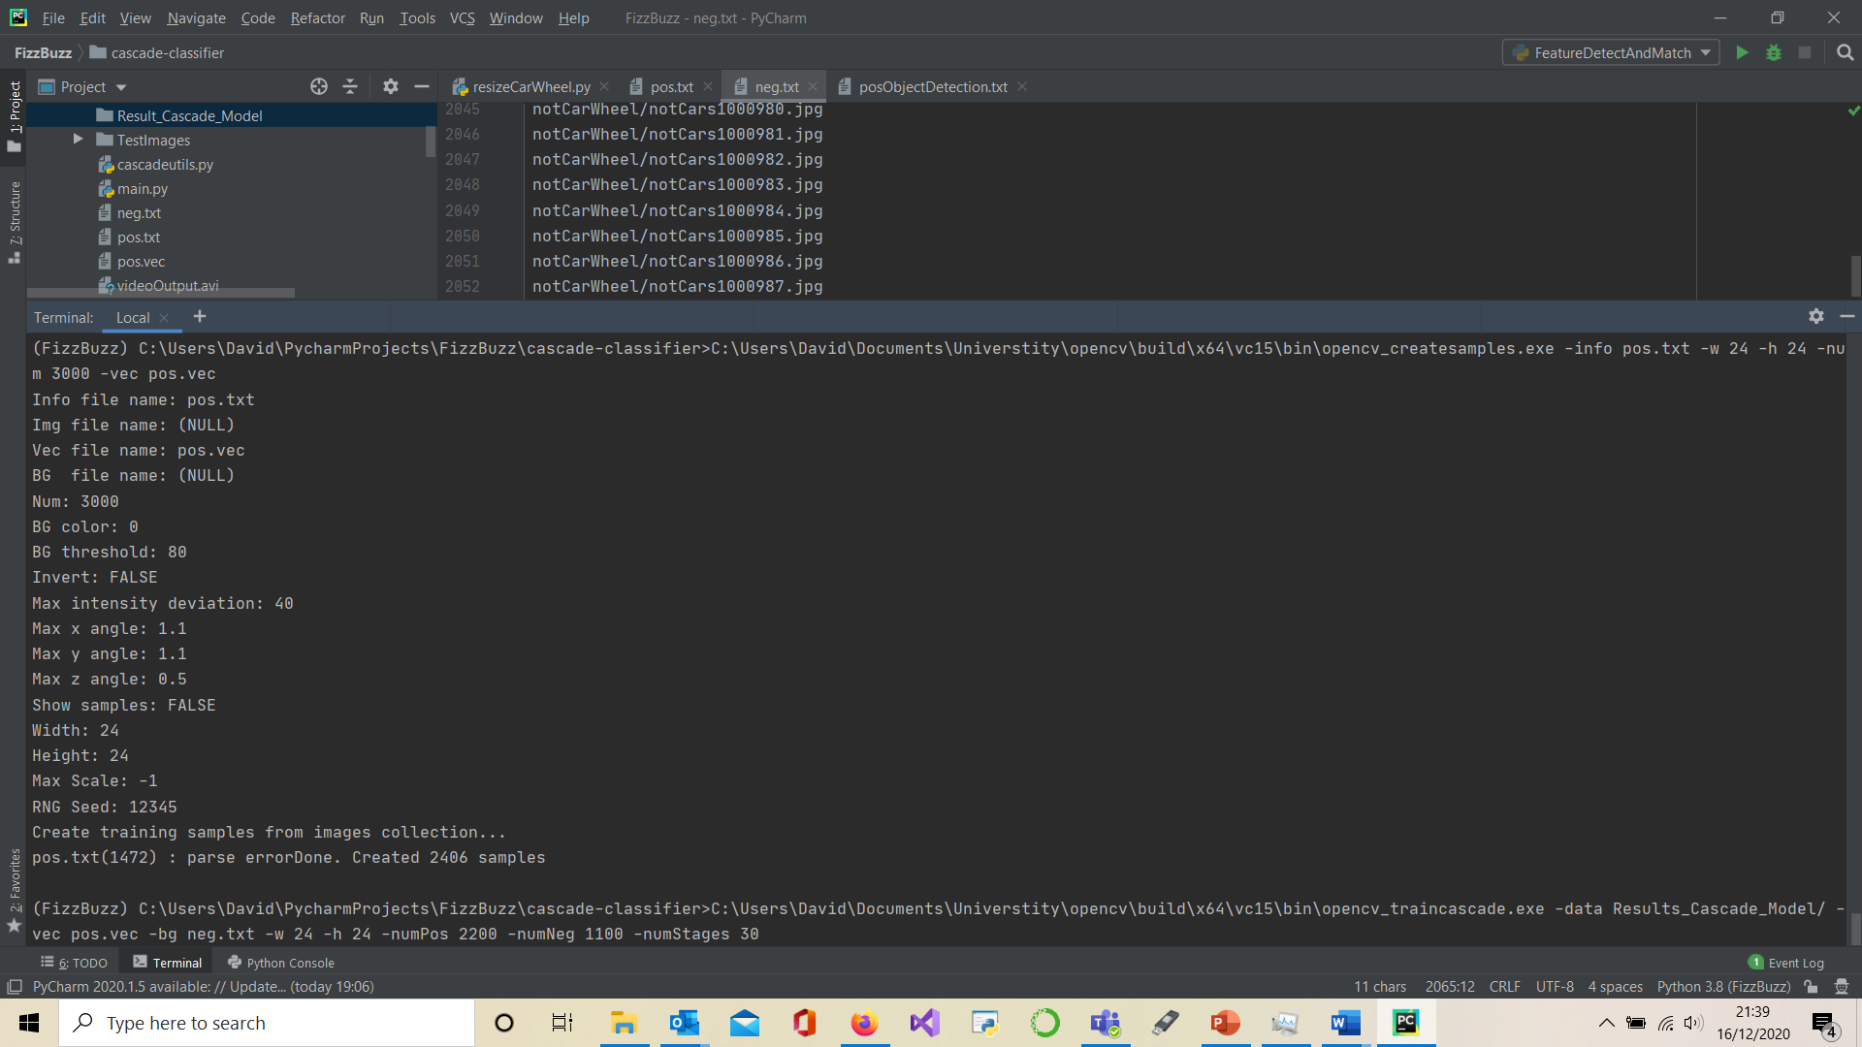

Figure 38: Image of the last data preparation step. The command in the last line of the terminal would start the training of a car wheel detecting Cascade Classifier.

* + 1. Training the model

As with the data preparation, OpenCV 2.X on windows has an executable that can run the cascade training algorithm. The details are explained on the OpenCV website [17]. The figure 38 above has the command line filled out such that it would start the training process on this PC. In the figure 38 it can be seen that “2406 samples” were created. This is the number of positive examples (car wheels) annotated in the data preparation step. Training can be tuned so a high true-positive or lower false-positive rate is achieved. The model generated for this final implementation prioritises a high true-positive rate so it doesn’t miss any car wheels. The more stages a classifier has the better it should be, given each stage acts as its own independent classifier. Note that the cascade classifier training can be continued or modified part way through, allowing different datasets or parameters to be used. Another point to note is that the number of positive examples used during training must be less than the total number of positive examples.

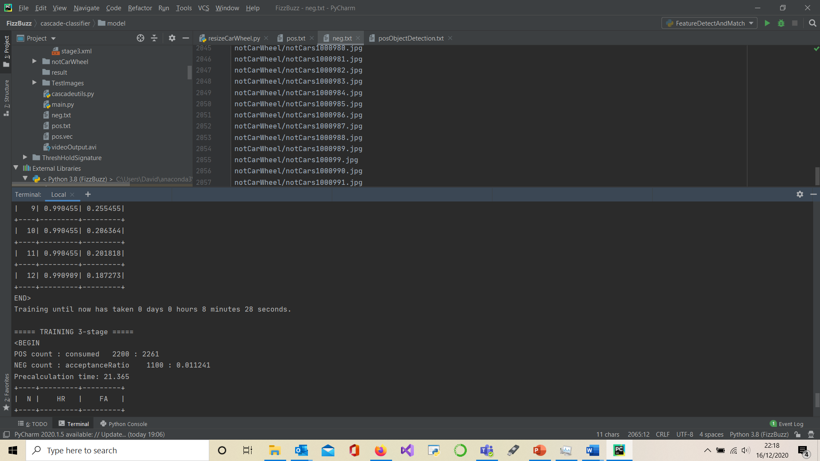

Figure 39: Example of the terminal during training. With the default setting the classifier will attempt to learn features that achieve a false positive rate below 0.2 and a true positive rate above 0.99.

* + 1. Usage of the cascade model

To use the cascade classifier model in the code two steps are performed. The first is to load the model: ***cascade_wheel = cv.CascadeClassifier(args["model"])***. The ***cv*** is the import of openCV2. Typically, it is named ‘cv2’. In this implementation it has been called ‘cv’. The ***args[“model”]*** is taking the user input for where the model is located. Alternatively, this can be replaced with a complete file path, or a partial file path in the same directory model. It would look along the lines of ***models/cascadeWheelClassifier.xml*** with the model name coming after the last forward slash. This step has created a Cascade Classifier object with a custom model, in the implementation it is called ***cascade_wheel***.

*The next step is to run the Cascade Classifier on an image:*

***rectangles = self.cascade_wheel.detectMultiScale(workFrame)***.*The* ***detectMultiScale*** is an inbuilt function of the ‘CascadeClassifier’ object that takes an image as an argument. In this case the image is called ***workFrame***. The output is a list of bounding boxes called ‘rectangles’. The rectangles can be used to output the location of potential car wheels or be sent for further testing.

* + 1. Results

The precision metric is very important as it relates the two metrics that matter for this project: precisions $=\frac{True Positive}{True Positive+False Positive}$. When image widths are reduced the image height is resized accordingly.

|  |  |  |  |  |
| --- | --- | --- | --- | --- |
| ***Data set of images with 600 width*** | ***True Positives*** | ***False Positives*** | ***Image with no False positives in negatives*** | ***Precision*** |
| 100 positives | 100 | 27 |  | 78.7% |
| 100 negatives |  | 295 | 29 |  |
| **Total** | **100** | **322** |  | **23.7%** |
| ***Data set of images with 300 width*** |  |  |  |  |
| 100 positives | 100 | 4 |  | 96.2% |
| 100 negatives |  | 108 | 28 |  |
| **Total** | **100** | **112** |  | **47.2%** |

Table 1: The results table of the Cascade classifier.

* + 1. Conclusion

Cascade Classifiers in general suffer from a high false-positive rate. This issue was evident when testing the cascade classifier car wheel detect model’s performance on a new data set. The share of images that made false-positives is uneven. Most of these mistakes occurred in the negative data set. More specifically in images taken indoors where the Cascade Classifier algorithms features matched patterns of dark and light areas of an image. So, it is probable that the lighting and varied surfaces created shadows and light areas that the cascade model cannot handle well. Improvements could be made by taking these false-positives and using them as negatives to train a new better model.

The cascade classifier cannot be used as a standalone classifier. Not unless another classifier is used to check the cascade classifier false-positives, hence the addition of a CNN to the project. This makes for a conventional object detection pipeline. The cascade classifier proposes bounding boxes in a frame of a video. The CNN validates these bounding boxes. Ideally the validation step removes all the false-positives.

Through experimentation it is found that feeding the cascade classifier an image that is only 300 pixels wide and rescaling the height accordingly prevents a lot of false-positives. This is because the image is too pixelated to identify anything other than “large” car wheel looking objects that are close to the camera. Downscaling the image effectively reduces the distance the cascade classifier will identify car wheels. For the car wheel removing robot at 300-pixel width is not an issue being that the robot’s operational space will be close to the wheel it has to remove.

The Cascade Classifier outputs square bounding boxes which can be a significant concern. This is an issue if the bounding box needs to tightly wrap around an identified object. In this project this might be the case if the angle of the car wheel relative to the robot must be ascertained.

## CNN with logistic regression models for image classification

* + 1. ***Introduction***

Convolutional Neural Networks are the most common solution these days for image classification. This is due to their accuracy and the greater availability of powerful hardware. In object recognition the output is the original image with bounding boxes surrounding known objects in the scene. Typically, CNN’s are paired up with other software that determines potential bounding boxes in the scene. For the final implementation of the car wheel detection a cascade classifier will perform this role. The CNN is then run on the patches of image inside the bounding box. The final output from the CNN is the given probability that the patch of image is a car wheel. As is the case with much of machine learning, most of the work came from training the model. Transfer learning is used to improve the training of the custom CNN. The use of CNN’s presented a major challenge due to hardware limitations. The speed taken to process a single image using a CNN on an average CPU make real-time object detection impossible using a standard object detection pipeline. To solve this issue multithreading and bounding box tracking was used and is further discussed in the “Working implementation” chapter.

* + 1. Direct transfer learning on CNN
       1. Data preparation

The data preparation for the CNN is similar to that of the Cascade Classifier but with a couple of additional steps. The positive and negative data collection is done the same. Thus, the data sets for the Cascade Classifier were reused. An additional step is performed to extract the car wheels image patches from the positive’s images. This is achieved with a script that reads in the CSV file containing the annotations of the car wheel bounding boxes locations. The negative data set was further improved after training the first models. When the CNN made false-positives, these images were added to the negative images, improving subsequent models. Hence why there are a lot of wing mirrors and car lights in the negatives folder. These data sets can then be separated further into Test, Validation and Training data sets. Each containing a dataset of positive and negative images.

In a binary classifier there should be an equal number of positive and negative examples. If these numbers are not equal the classifier can develop a bias for the positives or negatives.

* + - 1. Training the model

It is possible to build a model from scratch and then train the weights of the model using the training and validation data. This is not the best choice because it requires immense amounts of data to train a high-quality CNN model. Therefore, transfer learning is used. A first attempt at transfer learning used the CNN model MobileNet [18]. This prebuilt and pre trained model can be imported through Keras. It only has 4,253,864 parameters [19] which is much smaller than a more conventionally sized VGG16 which has 138,357,544 parameters [19]. The number of parameters mostly reflect weights which must each be tuned during training and computed during run time. As the name suggests, MobileNet was developed for less capable devices such as mobiles. Despite its smaller size the accuracy is still very good when compared to the much larger CNN’s.



Table 2: Table of available prebuilt and trained models on Keras [21].

In the first attempt the top 6 layers of the CNN were removed and rebuilt. The rest of the CNN’s layers are ‘frozen’. This freezes the parameters, so no training is performed on these layers. The top layers are rebuilt to converge into 2 classes as this is the number of classes the custom model will evaluate. This differs from the original model of MobileNet which trained on a subset of the ImageNet dataset. This contains about 1.4 million images with 1000 different classes. Being trained on this many images means the MobileNet model has excellently trained bottom layers.

This was a first attempt because an unclear technical difficulty meant the model was not correctly rebuilding the last layers. Due to time constraints another technique for transfer learning was performed. It is highly recommended that in future work this issue is resolved. The reasons for which will be discussed in the results section.

* + 1. Transfer learning on CNN with machine learning and feature vectors:
       1. Data preparation:

The data preparation for this method is similar to the previous section’s but with an additional step. A pretrained MobileNet model with its top layers removed is saved. The dense layers that converge the last convolution layer into the output layer were removed in this implementation. The additional step involves running every instance of every dataset through the unfinished MobilNet. The output of the MobileNet is taken in vector form (that is a vector in software development terms). These vectors are saved to a CSV file. Each entry in the dataset has a first column describing the class. The other columns will contain the output vector values of the entry.

In the case of the final implementation, running through the 1250 positive and 1250 negative images took roughly one hour to do on a 1.9ghz CPU. The result is a 10gb CSV file. This size constraint is something to consider when preparing the data. This caused issues during data preparation as the laptop had only several mb of data left after storing the 10gb CSV file. Hence why the dataset used in training is much smaller than total data prepared.

* + - 1. Training the model

The CNN model will be kept the same, maintaining its pretrained weights leaned from the ImageNet data set. However, the MobileNet model should not have the dense top layers that covert the last convolutional layer into an output layer. This is where the logistic regressor model is used and where training takes place. The logistic regressor model was picked because it is an algorithm that can separate nonlinear data. Typically, the sklearn [20] library would be used to generate these sort of machine learning models, but it is incapable of performing batch learning. In other words, it would need to load the entire CSV file into RAM. Given the CSV file for this project is 10gb and the RAM available was 8gb another software library had to be used.

Creme is a machine learning library that can perform incremental learning. The library handles much of the machine learning work, but some setup is necessary. Creme doesn’t require a validation dataset for training the model. Thus, even more examples can be fed into training the logistic regression model. An issue encountered was the model’s propensity to overfit or underfit. When overfitting the model would require less than 3 batches of 16 entries to achieve an accuracy of over 90%. When testing the results on a test set it is obvious the accuracy was closer to 50% which is random chance. Conversely, when the learning rate is lowered too much, the model does not learn anything. The accuracy stays around 50% for the binary classification. To solve this issue the learning rate had to be tuned through trial and error to a value of 0.0000001. Any higher or lower the model would underfit or overfit. With this learning rate the model would converge to an accuracy of 92% at 200 iterations.   
  
Creme is a very new library, so online resources on how to use it are somewhat limited. As of writing this paper the official creme website is offline. This is an issue to consider for future development of the car wheel detection software. The other issue is the CPU time taken to run a single vector through the logistic regressor. On a 1.9ghz CPU it takes on average 0.7-1 second which is too long for a real time piece of software.

* + 1. Brief code structure:

Running a prediction on a single patch of image works very similarly to how the CNN with machine learning was trained. Going onto the code of ***wheelDetectionTransferLearning.py*** there are 4 functions. An ***__init__()*** function that sets up the machine learning objects to determine if a patch of image is a car wheel. The ***prepare_image()*** function resized the input patch of image to 224 x 224 pixels so it will fit into the MobileNet input layer. The image preparation contains the line ***prepared_image = tf.keras.applications.mobilenet.preprocess_input(img_array_expanded_dims)***. The line of code takes the current image ***img_array_expanded_dims*** and performs colour manipulation. This colour manipulation was used when training the MobilNet and when generating vectors for the CSV file. The following function is used to generate the vector data from the prepared image: ***self.MobileNet.predict(prepared_image)***. This is a prebuilt function that comes with the MobileNet. The vector elements are placed in a dictionary object and then run on the model using: ***output = self.ML_model.predict_proba_one(dictionary)***. This outputs the probability of how likely an input image is a car wheel. In the current implementation it is assumed that a prediction above 50% is a car wheel.

* + 1. Results

The confusion matrix, shown below, displays the results of the CNN with Logistic regression used for transfer learning. The dataset used is similar to the one used for the cascade classifier. There are 100 car wheels and 100 non-car wheels. The car wheel images were extracted from the positive images using the annotations CSV file. To keep testing realistic the positive images were downsized to 600 pixels width. This is the output pixel width of the webcam used to empirically test the overall software’s performance. This downscaling will affect how blurry the extracted wheel images will be when resized to the CNN input shape of 224x224.

|  |  |  |
| --- | --- | --- |
|  | Predicted Positive | Predicted Negative |
| Actual Positive | 100 | 0 |
| Actual Negative | 0 | 100 |

Table 3: Confusion matrix of the CNN with Logistic regression model used for transfer learning.

An accuracy and precision of 100% are achieved as the algorithm does not make any mistakes on this data set. Further testing of the full pipeline has shown that the models do make occasional mistake. This will be elaborated in the “Working implementation” chapter.

The compute speed of a single output from the CNN with Logistic regression model used for transfer learning takes about 0.8s-1.1s. The CNN contributes about 0.13s and the Logistic regression contributes about 0.7s-1.0s to the total time.

* + 1. Conclusion

This combination of the MobileNet CNN and logistic regression models works well for image classification. This has sufficient accuracy to act as a validation step for the cascade classifier. This completes the car wheel detection pipeline. Increasing accuracy can be principally achieved in two ways, using better model architectures, and using better datasets. The main criticism of the custom models’ architecture is how transfer learning is done.

In the case of accuracy, it is adequate for a prototype, but a commercial product should perform better. In this implementation only the dense top layer is removed. Ideally the CNN should have even more top layers removed as the last convolutions in the network only capture high level semantic information on the different classes it was trained on. In the case of the pretrained MobileNet most of these classes are of no interest and probably produce noise that deteriorates overall accuracy. The improvement to a model’s accuracy from the training dataset size grows logarithmically. Meaning there are decreasing returns when more data is used. To improve the data set, the number of car wheel images could be increased to 10 000 images. Currently the size of the positive data set is 1250 images. It is important to get a variety of images too: different models, lighting, states of cleanliness and camera angles. The main criticism of the current data set quality is having too many car wheel images below 224x224 pixels.

The largest overall issue is speed. As aforementioned the CNN part runs in 0.1 seconds and the Logistic regression model takes 0.7-1 seconds on average on a 1.9hgz CPU. The speed is particularly bad and it’s recommended for future work to improve the transfer learning by retraining a CNN top layer rather than using a machine learning model such as logistic regression. Not only should it be faster, but the code and model will be easier to maintain. To point out why it should be faster: The removed dense layer of MobileNet represents about 1 million parameters, leaving the CNN with about 3 million parameters. If 3 million parameters take 0.13s to compute it’s reasonable to assume 4 million will take about 0.17s to compute. This is roughly 5.7 times faster than the current software.   
  
To solve the speed issue of the CNN and Logistic Regression algorithms operate on their own separate thread. Effectively these two machine learning algorithms act as new car wheel detectors and can run at their own speed. The rest of the code runs on the main thread and tracks bounding boxes. If a new car wheel is found it is added to the bounding boxes being tracked.

# Working implementation of car wheel detection

## Summary

A camera-based car wheel detection software was successfully developed during this project. The main challenge was getting the code to work in real time. This was achieved by coding a custom-made bounding box tracker that would circumnavigate the need to run expensive machine learning models. In addition, multithreading had to be implemented so the expensive CNN with Logistic Regression algorithms wouldn’t block the rest of the code whilst they were computing. Essentially the code works by having the CNN and Logistic Regression identify new car wheels on a sperate thread unrestrained by the issue of real time performance. The rest of the code acts in the main thread which is tasked with tracking the bounding boxes of known car wheels. Thus, the software has the accuracy of state-of-the-art object detection software and the speed of object tracking software so long as the object tracking doesn’t make any mistakes. The following chapter will give an overview of the working code structure, in particular the multithreading and optimisations.

## The main loop and video stream reader

* + 1. Introduction

The code discussed in this section pertains to the running of the car wheel detection system on a video feed. The main loop of the code exists in the ***findWheels*** class of the ***videoControl.py*** module. In the current version, the code outputs the results on a screen. The output video feed contains green bounding boxes around identified car wheels and displays the frame rate. What’s more, each car wheel has a number to identify it. In addition to calling the rest of the code to start detecting car wheels the ***findWheels,*** class handles the setup of the video feed, video output and some resizing of the input frames in order to improve software performance.

The library imutils made by Adrian Rosebrock [21] is used in this project. The WebcamVideoStream module comes from this library. It runs the input video in a separate thread. This is important as video streaming is an I/0 bound operation, meaning the CPU spends considerable time waiting for a video.

The ***findWheels*** code structure has two main steps: a setup step with the ***initialseVideoIntake()*** function and a repeating loop called ***runDetector()***. Inside ***runDetector()*** the cascade classifier is called to find potential car wheels in the current frame. The list of bounding boxes is reordered to prioritise the most likely bounding boxes and non max suppression removes duplicate bounding boxes. Finally, the list of bounding boxes is given as input to the ***drawBB.draw(…)*** function that executes the rest of the car wheel detection code. This returns an image that is then displayed.

* + 1. Video stream resizing

The input video stream can come in 2 forms. Video from a file and video from a webcam. In this implementation the car wheel detection code is command line launched using a command such as:  
***python videoControler.py -v TestVideo/CarPark.mp4 -m models/cascadeWheelClassifier.xml -w 300***

If no video file is given (-v) then the code defaults to using the webcam. It’s worth noting that an inbuilt webcam’s feed usually comes from ***src = 1***. USB webcams will therefore use a different ***src***. Attention should be given to which value in ***src*** is written for getting the webcam to work. The size of the video frames depends on the input device, this size is represented by the number of pixels in the horizontal and vertical axis. In the code only the image pixel width is discussed, that's because new pixel heights are automatically rescaled relative to new image widths. There are 3 image sizes used throughout the code: The **originalFrame** image size taken directly from the video stream, the ***displayFrame*** size and the ***workFrame*** size which is used as input to the cascade classifier.

The ***displayFrame*** frame size is simply the resolution the result is displayed at. It is set to a width of 1000 pixels unless the input resolution is lower than 1000 pixels width. This means the output display should fit on any modern screen.

The ***workFrame*** size of input video frames are used in the cascade classifier. The cascade classifiers performance is linked to the size of the input image. Larger images take longer to compute. Far away Objects are more visible in larger images on account of the higher pixel density preserving the objects detail. Experimentation has also shown that higher resolution also increases the number of false-positives output by the Cascade Classifier algorithm. For these reasons, the **workFrame** is downscaled. The car wheels will never be far away from the car wheel removing robot, so there is no appreciable downside to downscaling the input image. So long as the image is big enough for the Cascade Classifier algorithm to identify wheels up to the required distance. The ***workFrame*** can be modifier with the ***-w*** input argument. From empirical experimentation, setting the value to ***300***-pixel width was found to work best.

The **originalFrame** is the raw input video. This is used in the rest of the code. This is because computer vision operations tend to work better on higher quality images.

* + 1. Additional features
       1. Minimum frame time

A timer makes a video frame take a minimum amount of time to compute. This has implications in the multithreading of the code. The secondary thread needs to catch up with the main thread to merge data. This is made more difficult if the main thread is running faster than processed.

* + - 1. Video Recording

By adding the argument ***-r 1*** the display video is recorded to memory. It is worth remembering that that recording data to memory is an I/0 bound task. As a result, the code runs a little slower. This should not be noticeable as the code is artificially set to run at 10 fps

* + - 1. Reorder Bounding boxes

There are 2 benefits to reordering the proposed bounding boxes output from the cascade classifier. Because there is a maximum amount of time of approximately 0.1 seconds allocated to processing a single fame, priority to the bounding boxes most likely to be a car wheel should be given.

Testing a bounding box with the CNN and Logistic Regression takes about 1 second. This is the only way of confidently validating a bounding box as being a car wheel and it can only be done about every 11 frames. Hence why it is a good idea to take a guess which bounding boxes contain car wheels instead of relying on pure luck. Another reason for ordering the bounding boxes is on the off chance that there isn’t enough time to perform ORB feature matching on all the proposed bounding boxes. This is a problem that could occur if the cascade classifier proposes a large number of bounding boxes. Such a situation occurs when running the cascade classifier on higher resolution scale images.

The bounding boxes are reordered inside the ***findWheels.runDetector()***. The assumptions made are bounding boxes which are bigger and closer to the vertical centre of the image are more likely. These two parameters are normalised and multiplied by coefficients so they can be easily tuned. These assumptions stem from how the car wheel detection software will operate if used on a car wheel removing robot. The camera will be placed on the robot at roughly the same height as a car wheels central point. As the operations of car wheel removals take place on flat surfaces, all car wheel central points and by extension the central points of their bounding boxes will be located around the vertical midpoint of the input video feed. The other assumption is that bounding boxes closer to the camera are more likely to be a car wheel. The wheel removing robot should be placed close to the car whose wheels need unbolting

## Car wheel proposal areas and confirmation

* + 1. Car wheel proposal areas

The ***videoController.py*** module was originally designed to run the cascade classifier car wheel detection model on a video feed. As it was clear that the cascade classifier model managed to achieve a high recall rate (high true-positives) but have poor precision (high false-positives) an additional verification step needed to be added. Hence the addition of a CNN and Logistic Regression which is indirectly called from **drawBB.draw(…)** in **findWheels.runDetector*()***. This is a typical object detection pipeline. Proposal areas are generated by a fast algorithm and these proposal areas are run on a CNN for validation. In this implementation validation is achieved with the ImageNet trained MobileNet CNN model combined with a custom Logistic Regression car wheel detection model to leverage the benefits of transfer learning. Cascade classifiers are not a typical method for generating proposal areas.

Whilst they offer excellent speed there are two major drawbacks for Cascade classifiers: A model can only identify a single class of object making it only useful for binary classification. Multiple Cascade Classifiers models can run on the same image, but the compute time will multiply with the number of classifiers being run simultaneously. Making cascade classifiers impractical for multi class object detection. The other drawback comes from the false-positive rate.

The conclusion is that a cascade classifier is a good way to propose bounding boxes in an image, providing the object detection is a binary classification problem. Cascade Classifiers have an additional drawback to be aware of. The bounding boxes output are always square so in an implementation where the bounding box size matters cascade classifier are not suitable for proposing bounding boxes.

* + 1. Car wheel confirmation

The confirmation of a bounding box currently uses a pretrained MobileNet CNN model and a custom trained logistic regression car wheel detection model that acts as the top layers or the pretrained CNN. The code for this doesn’t differ from the experimentation done in High-Level computer vision section.

The major drawback of the current model is the time taken to run the logistic regression. It is therefore highly recommended a new model is trained using a pretrained CNN. However, instead of using a logistic regression model as the top of the CNN, the CNN top layers. This should increase the speed of the bounding box confirmation by about 570%.

## Draw the bounding boxes:

* + 1. Overview

The ***drawBB*** object is tasked with drawing the bounding boxes. It also controls the use of the bounding box tracking and the CNN and Logistic Regression thread. The major idea to speed up the code was to avoid computing a bounding box that is in the same position in frame t and frame t+1. If the bonding box is in roughly the same position and roughly the same size, it’s safe to assume that this bounding box contains that same object in frame t and frame t+1. This presented 2 major obstacles:

1. Tracking a bounding box from frame t to frame t+1 only works if the frame rate of the code is high enough. This is easy to conceptualise, if the robot that removes car wheels identifies a bounding box at frame t as being a car wheel it will turn towards the bounding box. Assuming the robot turns at a constant angular rate θ the position of that same car wheel bounding box will depend on how quickly it takes to update from frame t to frame t+1. In a real-world application, there will be more than one bounding box, so it is unsafe to assume a bounding box at frame t and frame t+1 contain the same object unless they are very close to one another. Which can only constantly happen if the frame rate is fast, or the robot moves very slowly.

The CNN with Logistic Regression takes about 1 second to complete. This means a single update from frame t to frame t+1 takes over 1 second. A lot could happen in that 1 second making the bounding box outdated by the time it is validated. This was the inspiration for putting the CNN and Logistic Regression on a separate thread and have it later catch up and merge with the main thread. This means the rest of the code could run at a more reasonable speed.

1. Edges cases would cause issues for the bounding box guessing. A common issue would be for the bounding box of a car wheel at frame t+1 being a little too far away from the prior bounding box that has been confirmed to be a car wheel at frame t. There is too much uncertainty to reliably use the bounding box matching. Using the CNN with Logistic regression to check these bounding boxes would be computationally expensive given that these edge cases happen too often.

ORB feature matching is used instead. When a bounding box at frame t+1 has no clear bounding box from frame t to match too, the ORB features of the bounding box at t+1 are compared to the ORB features of known car wheels. This has an added benefit of being able to consistently identify a specific car wheel.

## Code optimisation:

* + 1. ***Introduction***

The goal of the code optimisation is to achieve reliable car wheel detection in real-time. This is achieved by implementing multithreading and by using custom code to track bounding boxes in a video feed. This approach means that even low-end hardware should be able to run the software. The main thread is dedicated to running most of the code and can run with very little computational power. To summarise the idea behind the software: the main thread performs object tracking in a video. The CNN and Logistic Regression with information from the main thread performs object detection on an image.

Inside this main thread is a dictionary of known car wheels. This is a dictionary in computer science terms. These car wheels are more specifically ***boundingBoxObject*** objects possessing several attributes. The most important of these are the last known bounding box of the ***boundingBoxObject*** and the latest ORB features. If this dictionary of car wheels contains a set of car wheels at frame f then at frame f+n the main loop will still be able to identify all the car wheels of the set. Failure to do so means the main thread lost track of the car wheel(s) ***boundingBoxObject.***

The CNN and Logistic Regression’s task is to update the dictionary of car wheels. The CNN and Logistic Regression is the computationally demanding part of the code and has been put on a sperate thread as to not ‘freeze’ the rest of the code. This means the speed the CNN and Logistic Regression takes does not impact performance of the overall code asides for how fast new car wheels are identified.

* + 1. None threaded
       1. Artificial frame rate

In **drawBB.draw(…)** a timer makes this method call loop until all the bounding boxes of the current frame have been checked for car wheels or 0.1 seconds has elapsed. This acts as a maximum time a frame takes to complete. Inside the main code loop called ***findWheels.runDetector()*** a minimum time for a frame to complete is set to 0.08 seconds.

A maximum time for a frame to process increases the number of frames per second. Effectively making the code run quicker. This was implemented to mitigate the edge case where too many false-positive bounding boxes are generated. The minimum time for a frame allows the CNN thread to catch up and merge with the main thread quicker. Effectively increasing the number of CNNs that can be computed per minute.

* + - 1. Quick check bounding box

In ***drawBB.draw(…)*** a loop iterates through the list of bounding boxes. In each iteration of the loop the patch of image inside the bounding box, which can also refer to as the Region Of Interest (ROI) is first checked by a bounding box matcher. If this very quick operation fails, the nearest known car wheel’s ORB features are matched against the ORB features of the bounding box currently being tested. If this fails, then the ORB features of each known car wheel are matched against the ORB features of the bounding box currently being tested. If all these tests fail, it is assumed this bounding box has not been tested by the CNN and Logistic Regression before. If the CNN and Logistic Regression thread is not currently active a new CNN and Logistic Regression thread is launched to determine if the bounding box is a car wheel. At this point the code moves to the next bounding box that needs validating.

* + 1. Threading
       1. Brief expiation of threading:

A thread is a queue of instructions that are executed by a central processing unit (CPU). If a CPU ran a single thread, then multiple programs couldn’t run simultaneously. Multiple threads can be run ‘simultaneously’ by quickly swapping from one to another. This gives the illusion the CPU is executing both queue of instructions at the same time. Threading does not execute code quicker. Multiple threads can be used to make better use of a CPU’s resources. If a CPU is waiting for data to be retrieved to execute code on thread A, instead of doing nothing it can use the free CPU execution cycles to run thread B, C … until the data for A arrives. Threading is used in the car wheel detection code to prevent the CNN and Logistic Regression code from ‘freezing’ the rest of the code. This is important because the main thread performs bounding box tracking, which can only be achieved reliably at high frame rates.

* + - 1. How the code is threaded:

Threading was achieved in python by first importing ‘concurrent.futures’. The following figure shows the code block that launches a thread.

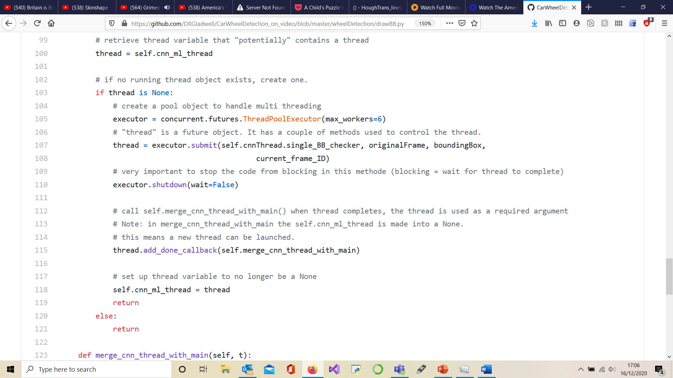

Figure 40: Code for running the CNN in a thread.

Of note the **executor.submit()** takes for first argument the method to be launched in a separate thread. This is how the CNN thread is launched. The **executor.shutdown(wait=False)** prevents the main thread from pausing whilst thread pool is executing which would defeat the purpose of the thread. The **thread.add_done_callback** takes for first argument the method to be called when thread finishes executing. This is useful to merge the thread back into the main thread. In the car wheels detection software this call-back makes sure the dictionary of car wheels is updated correctly. There is a possibility both threads could attempt to access the dictionary at the same time leading to data erasure. Thus, code has been added to make the dictionary thread safe.

* + - 1. Video Buffer:

A single CNN with Logistic Regression process takes around 1s to complete. As an example, the CNN with Logistic Regression has identified a car wheel in a bounding box at frame f. It is also assumed the code is running at 10 frames per second. If the camera was moving it is highly likely the car wheel is no longer located at the same point on the screen at frame f+10. It is necessary to find which bounding box, if any, at frame f+10 contain the car wheel identified at frame f. The Video Buffer object saves the last 120 frames of the video feed into memory. In addition to this it saves the location of each potential bounding box of 120 frames. All the bounding boxes asides though containing a car wheel.

* + - 1. Code to catch up secondary thread to main thread:

The Video Buffer object is updated by the main thread and read by the CNN thread. Much the same as **quick_check_BB**, the **quick_check_bb_thread** code is used to track a single bounding box that contain a car wheel at frame f to frame f+1. Being run in the secondary CNN thread after the CNN and Logistic Regression algorithms has finished computing means the **quick_check_bb_thread** code is run very fast. To improve overall performance the main thread has been kept at a maximum speed of around 11fps. As a result, the video buffer is updated less frequently speeding up the merger between the two threads. Testing performed on a 1.9 Ghz CPU showed the **quick_check_bb_thread** computes 3 frames for every new Video Buffer frame. Thus, the secondary take about 0.3s to catch up to the main thread.

* + - 1. Merge threads:

The **quick_check.add_potential_carwheel()** method of the module **quick_check_BB.py** adds a car wheel to be merged in the next frame of the main thread. **quick_check** class has additional code that verifies that the car wheel is new and is present in the current frame. Otherwise, the car wheel will never be added. Lastly, **self.lock.acquire()** and **self.lock.release()** are put around code blocks that need to be made thread safe. This means only one thread at a time can run the code between .**acquire()** and .**release().**

# Performance and Discussion

* + 1. Performance of Cascade and CNN object detection pipeline

The Cascade Classifier is used in the Car Wheel detection pipeline to identify potential car wheels in a frame of the video stream. These potential bounding boxes will only be confirmed as car wheels if validated by the Car Wheel image classifier. A CNN with Logistic Regression model used for transfer learning is used for this validation step. Their performance will be measured the same as the Cascade Classifiers performance was measured. The standard way to measure object detection is to use the intersection over union (IoU) metric.



Figure 41: Visualisation of the intersection over union formula.

If the IoU metric if higher than 0.5 the bounding boxes are counted as a match. Higher IoU scores are better, with 1 being perfect. The precision metric is very important as it relates the two metrics that matter for this project: precisions $=\frac{True Positive}{True Positive+False Positive}$. The changes in pixel width of an image are reflected in the pixel height which is resized proportionally.

|  |  |  |  |  |
| --- | --- | --- | --- | --- |
| ***Data set of images with 600 width*** | ***True Positives*** | ***False Positives*** | ***Image with no False positives in negatives*** | ***Precision*** |
| 100 positives | 100 | 2 |  | 98% |
| 100 negatives |  | 16 | 90 |  |
| **Total** | **100** | **18** |  | **84.7%** |
| ***Data set of images with 300 width*** |  |  |  |  |
| 100 positives | 100 | 0 |  | 100% |
| 100 negatives |  | 6 | 95 |  |
| **Total** | **100** | **6** |  | **94.3%** |

Table 4: The results table of the Cascade classifier.

The Cascade Classifier’s precision at 600 pixels width and then 300 pixels width is 23.7% and 47.2% respectively. The results in the table above are clearly much higher, at 300-pixel width the precision is sufficient to use in prototyping a car wheel removing robot. A recuring mistake the wheel detection software would make looks as follows:

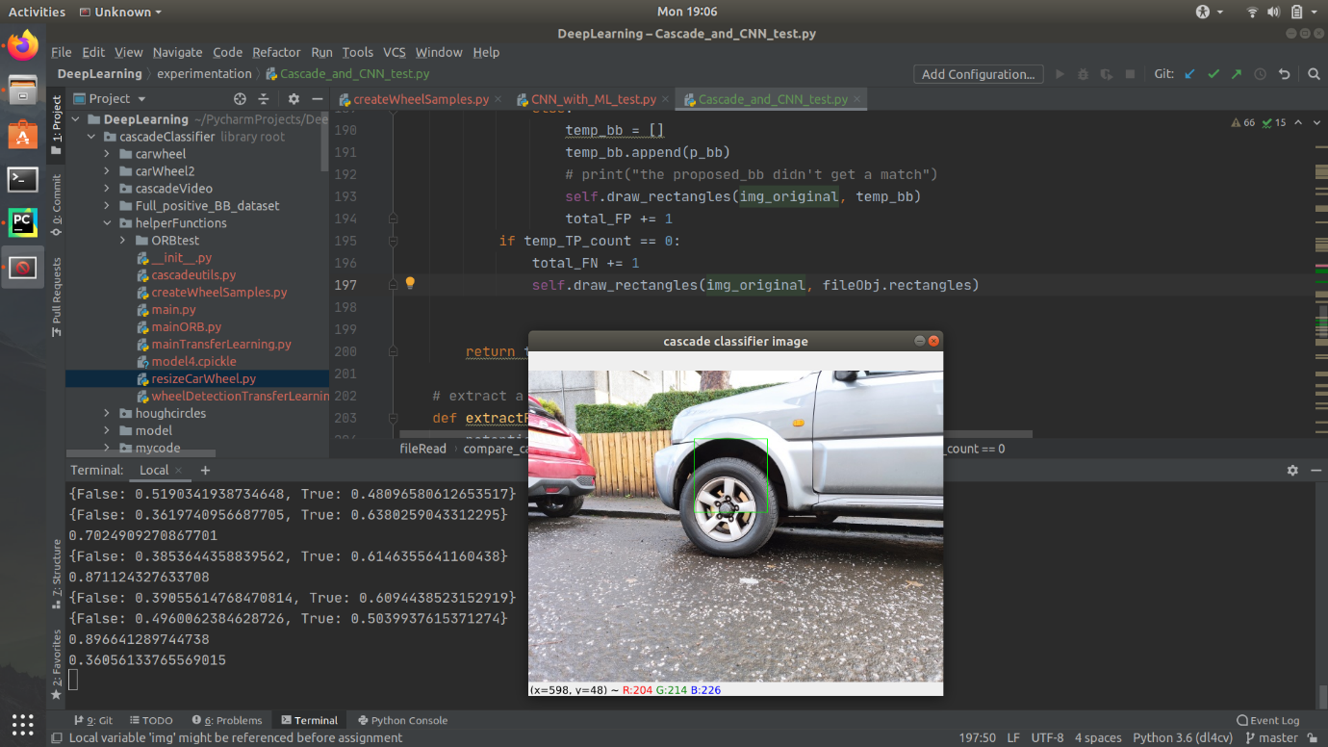

Figure 42: Example of common mistake produced during testing of car wheel detection software.

Precision can be further improved by increasing the threshold at which the Logistic Regression algorithm will classify an image as a car wheel. In the table 4 above the threshold is set to **0.50**. With the threshold set to **0.52** and performing the same test at 600-pixel width the precision goes up to 96%. This is without missing any true-positives. The precision will eventually go down as the number of true-positives found decrease too. For the final implementation, a threshold of 0.52 is used. Further tweaking of the threshold to adapt to the user’s requirements can be done but complete elimination of false-positives is impossible.

* + 1. Overall car wheel detection software performance

There are no experimental results as testing object detection in a video feed is very difficult. The results discussed will therefore be based on empirical evidence.

The precision of the software is good so long as the bounding box tracking does not make any mistakes. The common mistake to occur is when the tracking of a car wheel bounding box swaps with the tracking of another bounding box. This only occurs in an edge case where the last known position of a car wheel is at the edge of the camera feed and a new bounding box appears at the same place with the same size. Adding an extra ORB matching test on bounding boxes that appear just at the camera edge would mitigate this issue. Another problem with bounding box tracking occurs when the camera moves too quicky. If the movement is too quick, then ORB feature matching doesn’t work at all. Experimentation showed that this is because the new images are blurry and didn’t generate matches with the ORB features associated with the bounding object being tracked. A better camera might mitigate this issue. In practice this shouldn’t matter because the car wheel removing robot shouldn’t be moving fast. There is a limit to the size of the car wheel object dictionary. Car wheels that haven’t been seen in a while get deleted from the dictionary to make room for new ones. This reduces the chance of car wheel objects accidently swapping.

The perceived speed of the algorithm is really the speed of the main thread, which is artificially set at about 11fps. The main thread could need more computation time in the unlikely case it had to handle more double-digit number ORB test which individually takes 0.02 seconds. In practice the need for a double-digit number ORB test should only occur occasionally. When this happens its multiple bounding boxes are difficult to track and need to use ORB test. The code will update these bounding boxes one by one over a few frames until they are all correctly updated. From a user perspective the bounding box of a car wheel is lost for less than a second. The fact there is a limited number of car wheel objects means only a limited number of ORB tests need be performed if an exhaustive ORB search is required. The secondary threads speed performance does not matter to the user asides for time delay for new car wheels to appear. If the time to compute a single CNN with Logistic regression becomes really slow then it is possible the code to catchup and merge with the main thread will run slowly too. This can get to a point where either the video buffer for catching up to the main thread is too small or the secondary thread will never catch up to the main thread. This will only happen in the event the CPU hardware is very slow.

In summary the software performance is adequate. The precision the CNN with Logistic regression bring to the software is very good and the cascade classifiers excellent true-positive return rate make the system precise at detecting new car wheels. The object tracking is not as reliable as it could be with further development. The car wheel detection software is more than adequate for prototyping. The overall software is very good at detecting car wheels in a garage environment but might struggle to adapt to other problems.

# Conclusion

## **What was achieved**

Software capable of detecting real-world car wheels using an average laptop and low budget webcam was developed. More accurately part of the software detects new car wheels in a video feed and the rest of the code performs bounding box tracking. By putting the new car wheel detection and bounding box tracking in two different threads they can both be run at the same time. This is how real-time car wheel detection is achieved without compromising too much on precision. For the task of car wheel detection, this setup presents only one major risk: the bounding box tracking making a mistake.

A couple of goals were not met during this project. Detection of car wheel hubcaps and lug nuts was abandoned around 1/3 into the project. Hough Eclipse or Circle transforms algorithms are well suited for these tasks, but as discussed in this report they are sensitive to changes in lighting. It is much better to develop the detection of car wheel hubcaps and lug nuts once a physical prototype is designed. Doing so will allow for easier fine tuning of the algorithms or even adding a light near the camera to control the lighting conditions. The other goal that was not met was accessing what the angle of the car wheel is relative to the robot. This is an unfortunate side effect of the cascade classifier which only produces square bounding boxes.

The most interesting takeaway from this project is how object tracking can be used to speed up object detection tasks, bypassing the computationally expensive but accurate computer vison models in real-time camera tasks.

The project was ended once an adequate car wheel detection software was developed. The quality is good for an autonomous car wheel removing robotic prototype. The car wheel detection software will need further improvement to achieve sufficient precision and reliability in a commercial product. The project has ended at a good point, as it leaves the opportunity to improve the car wheel detection software in a variety of ways.

## Recommended future work

* + 1. Most important work

Improve the validation step speed by no longer using a CNN with a Logistic Regression to classify images. The Logistic Regression algorithm takes too long to compute, so creating a standalone CNN will speed up the code. Instead of using MobileNet, MobileNetV2 should be used as the pretrained CNN.

Use a different bounding box proposal algorithm than a cascade classifier. The cascade classifier produces square bounding boxes which does not give any information on the car wheels orientation. Depending on how navigation is achieved, the angle of the robot relative to the car wheel may need to be known.

* + 1. **Improvements on *the car wheel detection models***

The current project goal was to make a car wheel detection system that has reasonably good accuracy and can work on an average laptop CPU. There are a few ways to improve the validating step in the object detection pipeline. If hardware limitations are not a concern better and bigger CNN models can be used. This improvement will be marginal but can make a difference in a commercial application. The Nvidia Jetson [22] line of single board computers is especially interesting in this regard. They possess a good quad core CPU, run Linux and most importantly possess a 128-compute core GPU. This makes them perfect for machine learning tasks such as computer vision. A holistic approach to object detection would eliminate the need for separate bounding box proposal software. Using the YOLO [12] object detector would forgo the need to use the cascade classifier. It’s worth remembering that whilst it runs quickly for a state-of-the-art CNN the accuracy of the YOLO algorithm isn’t the best.

If compute speed is still a concern, converting a CNN model built using tensor flow into tensor flow lite would dramatically increase the CNN speed. The speed up is a result of the model no longer using 32-bit floats in its parameters but instead uses 8-bit integers. This comes at a minor loss in accuracy. The conversion to TensorFlow lite only makes sense if the CNN used does not have the logistic regression model working as the top layers.

Improving the training data set will improve the model’s performance. To increase the datasets quality, it is recommended to get real world data using the camera the car wheel removing robot will use.

* + 1. Other recommendations

In the current version of the code ORB feature matching is used to check if two image patches contain the same object. The Histogram of Orientated Gradients(HOG) of the image patches will probably work more reliably than ORB features. This should be investigated if the current bounding box tracking code is being improved.

The hub caps of car wheels will need identifying and removing needs. Their identification can be achieved using Hough circle transform. If there is no circle that could be the hub cap is can be assumed that the car wheel detection is a false-positive. This also works as a final validation step to prevent the robot from causing any physical damage.

Instead of using a cascade classifier a new technique can be used to propose bounding boxes. A model such as Histogram of Orientated Gradients(HOG) with support vector machine (SVM) would be ideal. The HOG with SVM could be used in conjunction with a sliding window to propose car wheels for the CNN.

# Annex

* 1. Hardware and software setup

Code language: Python 3.8.3

Important libraries: OpenCV 4.3.0, OpenCV 2.0

IDE: PYCharm

OS: Windows 10 and Ubuntu

* 1. Link to Code

<https://github.com/DRGladwell/CarWheelDetection_on_video>

* 1. link to Data sets

<https://heriotwatt-my.sharepoint.com/:f:/r/personal/drg1_hw_ac_uk/Documents/Datasets%20for%205th%20year%20wheel%20project?csf=1&web=1&e=b2HQXJ>

## Plan of work

A couple of external factors impacted important decisions made throughout the project. Firstly, the resources to develop the project were limited. The physical hardware available was a laptop with no dedicated GPU and due to poor internet access AWS (amazon web services) was impossible. This moved the project towards a solution that requires very limited computer hardware. Secondly, prior years attempts at the project were unsuccessful. With that in mind a decision was made to take a hands on approach with research, exploring many different techniques by reading their theory and attempting their implementation. These motivations yielded a working car wheel detection implementation that can work off an average laptop.

## References:

|  |  |
| --- | --- |
| [1] | IBM, “Ibm.com,” [Online]. Available: https://www.ibm.com/topics/computer-vision. [Accessed 2020 08 12]. |
| [2] | S. Papert, “ftp://publications.ai.mit.edu,” [Online]. Available: ftp://publications.ai.mit.edu/ai-publications/pdf/AIM-100.pdf. [Accessed 10 12 2020]. |
| [3] | R. Szeliski, Springer Publishing, 03 09 2010. [Online]. Available: http://szeliski.org/Book/drafts/SzeliskiBook_20100903_draft.pdf. |
| [4] | “web.ipac.caltech.edu,” 20 04 2009. [Online]. Available: http://web.ipac.caltech.edu/staff/fmasci/home/astro_refs/HoughTrans_lines_09.pdf. |
| [5] | E. Adel, M. Elmogy and H. Elbakry, “Image Stitching based on Feature Extraction Techniques: A Survey,” *International Journal of Computer Applications,* 2014. |
| [6] | M. Fischler and . R. C. Bolles , “Random sample consensus: a paradigm for model fitting with applications to image analysis and automated cartography,” *Communications of the ACM,* vol. Volume 24, no. Issue 6, 1981. |
| [7] | C. Stachniss, University of Bonn, Germany, 12 01 2016. [Online]. Available: https://www.youtube.com/watch?v=oT9c_LlFBqs&list=PL5_dGgbvVgqjQxm51rCzjCvnjQoYbiLvy&index=4&t=0s. |
| [8] | IBM, “www.ibm.com/cloud/learn/machine-learning,” IBM Cloud Education , 15 07 2020. [Online]. Available: https://www.ibm.com/cloud/learn/machine-learning. [Accessed 15 12 2020]. |
| [9] | H. Curry, “The method of steepest descent for non-linear minimization problems,” *Quarterly of Applied Mathematics,* 1944. |
| [10] | J. S.-H. Alexis Derumigny, “On lower bounds for the bias-variance trade-off,” Cornell University , 30 May 2020. [Online]. Available: https://arxiv.org/pdf/2006.00278v1.pdf. [Accessed 26 10 2020]. |
| [11] | P. &. M. Jones, “Rapid Object Detection using a Boosted Cascade of Simple Features,” 2001. [Online]. Available: https://www.cs.cmu.edu/~efros/courses/LBMV07/Papers/viola-cvpr-01.pdf. [Accessed 31 October 2020]. |
| [12] | J. Redmon, S. Divvala, R. Girshick and A. Farhadi, “You Only Look Once: Unified, Real-Time Object Detection,” *IEEE Conference on Computer Vision and Pattern Recognition (CVPR),* 2016 . |
| [13] | D. P. A. F. Vargas, *Biologically Inspired Computation,* Heriot-Watt, 2019-2020. |
| [14] | M. S. H. W. Kur Hornik, 9 March 1989. [Online]. Available: https://deeplearning.cs.cmu.edu/F20/document/readings/Hornik_Stinchcombe_White.pdf. [Accessed 1 November 2020]. |
| [15] | Y. LeCun and e. al., “Backpropagation applied to handwritten zip code recognition,” *Neural Computation,* 1989. |
| [16] | A. Krizhevsky, I. Sutskever and G. E. Hinton, “ImageNet classification with deep convolutional neural networks,” *Advances in Neural Information Processing Systems,* 2012. |
| [17] | “docs.opencv.org/3.4/dc/d88/tutorial_traincascade.html,” [Online]. Available: https://docs.opencv.org/3.4/dc/d88/tutorial_traincascade.html. [Accessed 16 12 2020]. |
| [18] | M. Z. B. C. D. K. W. W. T. W. M. A. H. A. Andrew G. Howard, “arxiv.org/abs/1704.04861,” 17 04 2017. [Online]. Available: https://arxiv.org/pdf/1704.04861.pdf. [Accessed 02 12 2020]. |
| [19] | F. Chollet, “keras.io/api/applications/,” various, but primarlily a team at google, [Online]. Available: https://keras.io/api/applications/. [Accessed 02 12 2020]. |
| [20] | Various, “scikit-learn.org/stable/,” [Online]. Available: https://scikit-learn.org/stable/. [Accessed 02 12 2020]. |
| [21] | A. Rosebrock, “github.com/jrosebr1/imutils,” Adrian Rosebrock , [Online]. Available: https://github.com/jrosebr1/imutils. [Accessed 2020 12 03]. |
| [22] | Nvidia, “www.nvidia.com/en-gb/autonomous-machines/jetson-store/,” Nvidia , [Online]. Available: https://www.nvidia.com/en-gb/autonomous-machines/jetson-store/. [Accessed 05 12 2020]. |
| [23] | S. Raval, “youtube.com,” 14 06 2019. [Online]. Available: https://www.youtube.com/watch?v=FSe_02FpJas. |
| [24] | S. Raval, “Github.com,” 24 July 2019. [Online]. Available: https://github.com/llSourcell/Learn_Computer_Vision. |
| [25] | J. Redmond, “youtube.com,” University of Washington, 11 09 2018. [Online]. Available: https://www.youtube.com/watch?v=8jXIAWg_yHU&list=PLjMXczUzEYcHvw5YYSU92WrY8IwhTuq7p&index=1. |
| [26] | D. M. P. U. o. Nottingham, “youtube.com,” computerphile, 19 10 2018. [Online]. Available: https://www.youtube.com/watch?v=uEJ71VlUmMQ&t=484s. |
| [27] | P. Adrian Rosebrock, “pyimagesearch.com,” [Online]. Available: https://www.pyimagesearch.com/. |
| [28] | U. Sinha, “aishack.in,” [Online]. Available: https://aishack.in/tutorials/circle-hough-transform/. |
| [29] | L. Jianzhuang, L. Wenqing and T. Yupeng, “Automatic thresholding of gray-level pictures using two-dimension Otsu method,” *IEEE,* 1991. |

## Figure References:

*Note: All other figures were taken or property of David Gladwell.*

**Figure 2 -**https://openframeworks.cc/ofBook/images/image_processing_computer_vision/images/lincoln_pixel_values.png

**Figure 3 -** https://www.programmersought.com/article/75784451502/

**Figure 4 -** https://www.geeksforgeeks.org/matlab-rgb-image-representation/

**Figure 5 -** https://www.quora.com/What-is-global-thresholding-in-image-processing

**Figure 6 -** https://www.youtube.com/watch?v=5xdbJ7z4Nrc&t=1970s

**Figure 7 -** https://chao-ji.github.io/jekyll/update/2018/07/19/BilinearResize.html

**Figure 8 -** https://chao-ji.github.io/jekyll/update/2018/07/19/BilinearResize.html

**Figure 9 -** https://chao-ji.github.io/jekyll/update/2018/07/19/BilinearResize.html

**Figure 10 -** https://medium.com/@bdhuma/6-basic-things-to-know-about-convolution-daef5e1bc411

**Figure 11 -** https://codegolf.stackexchange.com/questions/123039/plot-the-gaussian-distribution-in-3d

**Figure 12 -** https://www.opencv-srf.com/2018/03/gaussian-blur.html

**Figure 13 -** https://homepages.inf.ed.ac.uk/rbf/HIPR2/sobel.htm

**Figure 14 -** https://docs.opencv.org/master/d5/d0f/tutorial_py_gradients.html

**Figure 15 -** https://www.oreilly.com/library/view/computer-vision-with/9781788299763/29a4564e-fc34-41be-ad7b-0785a8ed7777.xhtml

**Figure 16 -** http://web.ipac.caltech.edu/staff/fmasci/home/astro_refs/HoughTrans_lines_09.pdf

**Figure 17-** http://web.ipac.caltech.edu/staff/fmasci/home/astro_refs/HoughTrans_lines_09.pdf

**Figure 18 -** https://aishack.in/tutorials/circle-hough-transform/

**Figure 20 -** http://szeliski.org/Book/drafts/SzeliskiBook_20100903_draft.pdf.

**Figure 21 -** http://szeliski.org/Book/drafts/SzeliskiBook_20100903_draft.pdf.

**Figure 22 -** http://szeliski.org/Book/drafts/SzeliskiBook_20100903_draft.pdf.

**Figure 23 -**https://www.cc.gatech.edu/classes/AY2016/cs4476_fall/results/proj3/html/xyuan39/index.html

**Figure 25 -** https://morioh.com/p/15c995420be6

**Figure 26 -** https://www.cs.cmu.edu/~efros/courses/LBMV07/Papers/viola-cvpr-01.pdf

**Figure 27 -** https://www.cs.cmu.edu/~efros/courses/LBMV07/Papers/viola-cvpr-01.pdf

**Figure 28 -** https://subscription.packtpub.com/book/big_data_and_business_intelligence/9781788397872/1/ch01lvl1sec21/feed-forward-and-feedback-networks

**Figure 29 -** https://medium.com/coinmonks/the-mathematics-of-neural-network-60a112dd3e05

**Figure 30 -** https://towardsdatascience.com/a-comprehensive-guide-to-convolutional-neural-networks-the-eli5-way-3bd2b1164a53

**Figure 32 -** https://docs.opencv.org/3.4/d4/d70/tutorial_hough_circle.html

**Figure 41 -** https://www.pyimagesearch.com/2016/11/07/intersection-over-union-iou-for-object-detection/